市南区2009——2010学年度第二学期六年级英语第12册综合练习（一）（时间：40分钟）

Listening Part 听力部分
Ⅰ. Listen and choose. 选出听到的单词或词组，并将其前面的字母标号填在题前的括号里。（10%）
( )1. A. three | B. thirsty | C. thirteen | D. thirty
( )2. A. raining | B. rain | C. rainy | D. rained
( )3. A. fun | B. funny | C. but | D. fun to
( )4. A. star | B. scared | C. stairs | D. start
( )5. A. past | B. night | C. because | D. birthday
( ) 6. A. spaceship | B. space travel | C. spend | D. spaceman
( )7. A. come true |  | B. came true
C. comes true |  | D. coming true
( )8. A. deaf B. blind |  | C .black D. bad
( )9. A. star B. scaring |  | C. scares D. scared
( )10. A. interesting B. exciting |  | C. interested D. excited

Ⅱ. Listen and tick. 根据录音内容，在相应图片下面的括号里划“√”表示。（10%）


1. 2.

（ ） （ ） （ ） （ ）
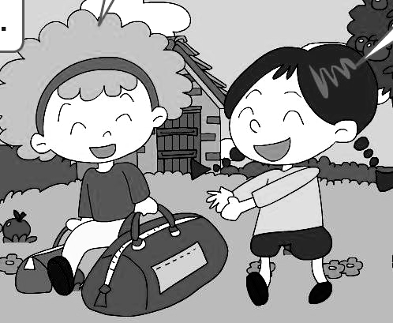
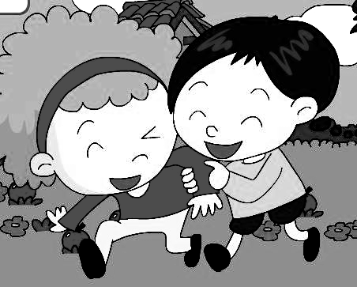
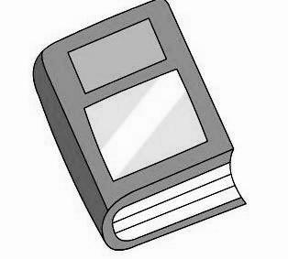
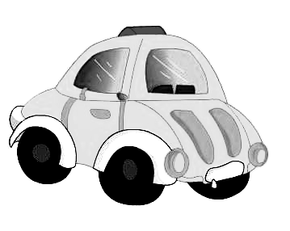
3. 4.

（ ） （ ） （ ） （ ）
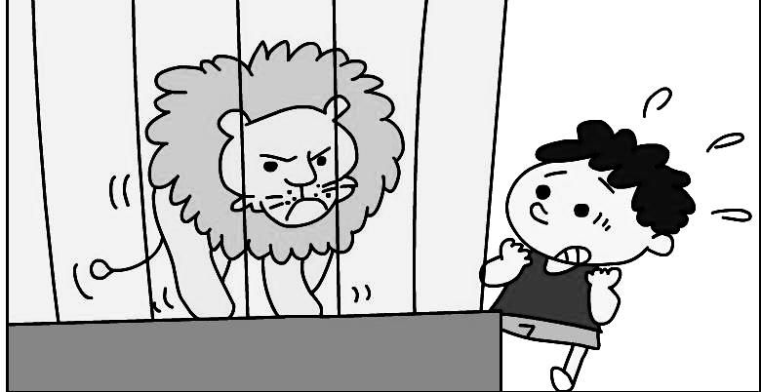
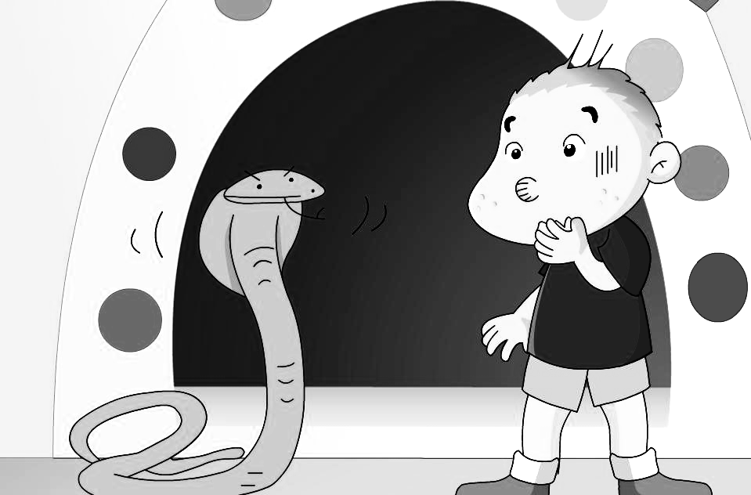
5.

（ ） （ ）
Ⅲ. Listen and choose. 听问句，选答语。（10%）
( ) 1. A. He eats a hamburger.
B. She is eating a hamburger.
C. I want to eat a hamburger.
( ) 2. A. We are going to eat hot dogs.
B. We are going to eat at twelve o’clock.
C. We are going to eat at the park.
( ) 3.A. No, I can’t.
B. Yes, we are.
C. Yes, we were.
( ) 4 . A. I bought a book for you.
B. Your mum give it to me.
C. Your mum give it to you.
( ) 5. A. I’m happy.
B. I’m ill.
C. He is laughing.
IV．Listen and judge. 听短文，判断句子是否符合短文意思,符合的用“√”表示， 不符合的用“×”表示。（10%）
( ) 1. Daming had a funny day on Sunday.
( ) 2. He went to the park with his father and mother.
( ) 3. It was sunny.
( ) 4. There was a big lake and there were many ducks.
( ) 5.Daming took some pictures for his dad and ducks.

V. Listen and complete. 听录音，补全短文。（10%）
Hello, my name’s Mike. I’m 11 years old. I _____ got short, black hair and blue eyes. I usually ____ to school by bus. I like _____ books. On Sundays, I often _____ my room. I am good at art. I ______ to be an artist in the future.

Writing Part 笔答部分
- Read and choose. 读一读，选出最佳答案，将其前面的字母标号填在题前的括号里。（10%）
1. I _____ a hot dog and Simon ____ a hamburger.
What do you _____?
A. want, wants, wants B. wants, want, wants
C. want, wants, want D. wants, want, want
2. Why are you ________?
A. scared B. star C. started D. sadly
3. I _______ swim then.
A. can B. can’t C. couldn’t D. able to
4. We’re going to _______ around the lake
A. walk B. walking C. walked D. walks
5. Tomorrow it’s going to ________.
A. sunny B. windy C. rain D. snowing
6. Why are you ________?
A. cry B. laughing C. laughing D. cried
7. In this photo, we are ________ our picnic
A. have B. had C. having D. has
8. All the planes are _______ away.
A. flies B. flying C. flied D. fly
9. Hold ______ to the balloons.
A. in B. on C. out D. of
10. He _______ and everyone _______.
A. stop, wait B. stops, waits
C. stop. waits D. stopped, waits
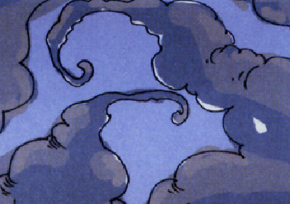
- Look and write. 看图补全句子，每空填一个单词。（10%）

- Look. It’s going to _______ _______.
（下雨）（马上）

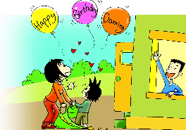
2. All the ________ are _______ away.
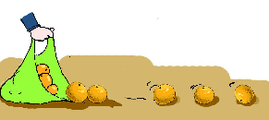
The _________ are ________.

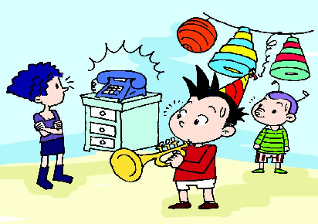
3. He is playing his _______,
But then the telephone _______.
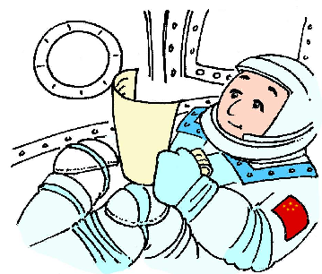
4. He ______ about 21 hours in ________.
(度过)

Ⅷ. Read and write. 按要求完成句子。（10%）
1.fifty, it, yuan, is, one hundred, and, fen(连词成句)

2. go, going to, to, park, the, when, we, are (连词成句)

3. a , I, on, had, funny, very, day, Saturday(连词成句)

4. Is it going to be hot? (请给出肯定回答)
______, it _______.

5. They’re jumping in the water.(就划线部分提问)
_______ are they _______?

Ⅸ. Reading. 阅读理解。(共15%)
. Read and judge. 读短文，用“√”“×”判断句子是否符合短文意思。（5%）
Daming, Simon and his dad are in an American restaurant. Daming wants a hot dog and a cola. Simon wants a hamburger and a cola. And dad wants a hamburger and a cola, too. In all, it costs thirteen dollars and twenty-five cents.

( )1. They are in a shop.
( )2. Daming doesn’t want a hot dog.
( )3. Simon’s dad wants a hamburger.
( )4. They order（点餐） two hamburgers, one cola and three hot dogs.
( )5. In all, the food costs thirty dollars and twenty-five cents.
.Read and choose. 读短文，选择正确答案。（10%）
Dear Jenny,
I ’m happy to write to you. I’m eleven years old now. And I’m at Tiantian Primary School. I am going to go to a new middle school in September. So I’m very excited!
Yesterday was my birthday. My mum cooked for me. And I invited lots of my friends to my birthday party. I played the piano and they clapped for me. Then we had a big and special birthday dinner.
My dad sent me a birthday present: a toy spaceship! It can fly in the sky! I want to drive a spaceship and be an excellent astronaut in the future. What about you?
From,
Linda
( ) 1. Linda is in __________ now.
A. primary school B. middle school
C. language school D. music school
( ) 2. Yesterday was ________.
A. Christmas B. Sports Day
C. Linda’s birthday D. Jenny’s birthday
( )3. Linda’s friends ________.
A. played the piano B. cooked for Linda
C. clapped for Linda D. both A and C
( )4. Linda’s dad sent her a _______.
A. toy plane B. toy doll C. toy house D. toy spaceship
( )5. What does Linda want to do in the future?
A. She will drive a train. B. She will drive a plane.
C. She will drive a spaceship. D. She will drive a car.
Ⅹ Composition.写作（5%）
同学们，你能给你的新英国笔友写一封信吗？简单介绍一下自己，比如：Which school do you go to? How old are you? When is your birthday? What does you dad do? What do you want to do in the future? 30-40 个单词。

___________________________________________________

___________________________________________________

___________________________________________________

___________________________________________________

___________________________________________________

Tapescript:
I
  - How much is it ? It’s thirteen dollars.(C)
  - Look. It’s going to rain soon. (B)
  - I had a very funny day. (B)
  - The apples are falling down the stairs. (C)
  - He is having a birthday party. (D)
  - The name of the spaceship is Shenzhou. (A)
  - Then his dream came true. (B)
  - Helen was blind. (B)
  - Why are you scared? (D)
  - I’m really excited. (D)
II.
- What do you want to drink? I want a cola, please.
- What’s the weather going to be like in Beijing? It’s going to be sunny.
- I can’t walk well. I’m very old. Can I help you? Thank you.
- I bought a book for you. Thank you.
5 Why are you scared?
Because there is a snake.
.
III.
1. What do you want to eat? (C)
2, When are we going to eat? (B)
3. Who can help me? (B)
4. Who gave it to you? (B)
5. What’s the matter? Why didn’t you eat? (B)
IV. Module 3 Unit 1
( v)1. Daming had a funny day on Sunday.
( v )2. He went to the park with his father and mother.
(x) 3. It was sunny.
(v) 4. There was a big lake and there were many ducks.
(x) 5.Daming took some pictures for his dad and ducks.
V.
Hello, my name’s Mike. I’m 11 years old. I have got short, black hair and blue eyes. I usually go to school by bus. I like reading books. On Sundays, I often tidy my room. I am good at art. I want to be an artist in the future.

听力：燕儿岛路第一小学 季本霞
笔答：宁夏路第二小学 高婕

