Listening Comprehension (听力部分)
- Listen and tick. (听音选图，在图下的括号里划‘√’表示。)(10%)


1．
( ) ( )


2。
( ) ( )
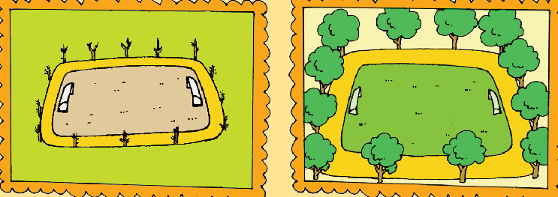
3.

( ) ( )
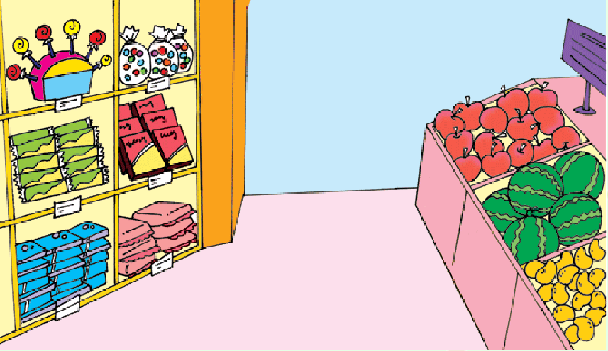
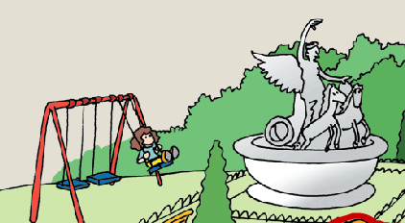

( ) ( )
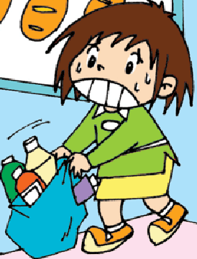

( ) ( )
- Listen and choose. (听问句，选答语。)(10%)
( )1. | A. Yes, you can.
 | B. No, thank you.
 | C. Please help me.
( )2. | A. I will go shopping.
 | B. I finished my homework.
 | C. I’m reading a newspaper.
( )3. | A. Yes, it is.
 | B. No, it can’t.
 | C. Yes, it does.
( )4. | A. It’s his.
 | B. It’s her skirt.
 | C. Sam wants to wear it.
( )5. | A. It’s July.
 | B. It’s January.
 | C. It’s April.
- Listen and write.(听一听，填上所缺单词，补全句子。)(10%)
- They go to __________ __________.
- They _________ the ___________.
- The film is ___________ __________.
- Is it _________ T-shirt? Yes, it’s _________.
- There ________ ________ cars here.
- Listen and circle.(听一听，圈出你听到的单词，补全短文。)(10%)
Look at the photo of my ( English / England ) friend, Amy. She’s wearing a beautiful Easter ( cap / hat ). There are toy ( chicks / rabbits ) and ( trees / flowers ) on it. Do you know ( Halloween / Easter )? It’s in ( spring / winter ) . People usually ( giving / give )children chocolate ( egg / eggs) . Some eggs are big ( or / and ) some are small. ( Children / They ) like them a lot.
V. Listen and draw ‘√’or ‘X’.(听一听，画对号错号。) (10%)
( )1. | Amy is going to be seven.
( )2. | She is going to have a party.
( )3. | Lingling is going to the party.
( )4. | Sam and Daming are going to play with Amy’s new toys.
( )5. | Lingling is going to help Ms Smart.

Writhing Part (笔答部分)
- Read and choose.(读一读，选择正确的答案。) (10%)
( )1.We _______ feed the ducks now.
A. could B. couldn’t C. can
( )2.Look! There are some tall ________ here.
A. trees B. a tree C. biscuits
( )3. Is it __________ schoolbag? No, it isn’t.
A. them B. his C. hers
( )4. Amy is going to _________ Mum tidy up.
A. had B. helped C. help
( )5. Are there ________ restaurants at the supermarket?
A. some B. any C. a
- Read and fill in the blanks.(根据图意，完成句子。) (10%)
- ---Are you going to ________ a _________ cake?
---Yes, I am.

- ---Look at your bag!
---Thank you! This ________ is ________.

3. There are many _________ and ________ here.

4. There was _______ a _______ here.

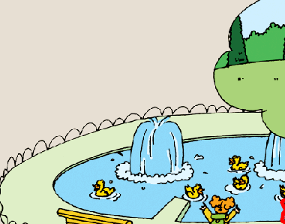
5. There wasn’t a _________ here __________.
- Reorder the words and write. (按照规范的书写要求连词成句。) (10%)
- an, festival, autumn, it’s

- not, it, is, hers

- are, what, we, going, do, to

- are, we, to, have, today, going, lunch

5. T-shirt, whose, it, is

- Read and judge ‘True’ or ‘False’.(读一读，判断‘True’ or ‘False’) (5%)
Many English supermarkets are very big. They sell different things. They sell food from lots of countries. They also sell clothes and toys and CDs. Many families go to the supermarket together.
( )1. | All English supermarkets are very big.
( )2. | You can buy different things there.
( )3. | They sell only Chinese fast food.
( )4. | You can’t find any T-shirts in the supermarket.
( )5. | Many families go shopping together.
- Read and choose.(读对话，选择正确的答案。) (10%)
Qiqi: What do you want, Mum?
Mum: I want to buy noodles, meat, eggs, fish and chicken.
Qiqi: Why, Mum?
Mum: Your dad is going to be forty. Let’s have a party.
Qiqi: Good idea! What are we going to do at the party?
Mum: We’re going to invite your grandparents and have lunch together. We’re going to sing a song to Dad. Also we’re going to give him a present.
Qiqi: Of course! That’s great!

( )1. | What are they doing? They’re _______ .
 | A. playing |  | B. going |  |  |  | C. shopping |  |  | D. eating
( )2. | Mum doesn’t want to buy ________ .
 | A. candy |  | B. fish |  | C. meat |  |  |  | D. chicken
( )3. | Who is going to go to the party?
 | A. grandma |  |  | B. Amy |  |  | C. grandpa |  |  |  | D. A&C
( )4. | What song is Qiqi going to sing?
 | A. Merry Christmas! |  |  |  |  | B. Hi! |  | C. Happy birthday!
( )5. | How old is Dad going to be?
 | A. 40 | B. 45 |  |  | C. 35 |  |  |  | D. 44
- Composition.(小练笔。) (5%)
写一写你的新年计划吧! 要求语句通顺，不少于3句话。
New Year’s Day is coming. What are you going to do?
______________________________________________________________________________________________________________________________________________________________________________________________________________________________________________________________________________________________________

录音内容
- 1. Jenny’s shoes are wet and dirty.
2. Is it an invitation? Yes, it is.
3. There was a small playground here.
4. Look! What a big supermarket!
5. Please help me put the bags in the car.
II. 1. Can I help you?
2. What did you do yesterday?
3. Does London look different now?
4. Whose jacket is it?
5. Which month is before May?
III. 1. They go to people’s houses.
2. They scare the people.
3. The film is really fun.
4. Is it your T-shirt? Yes, it’s mine.
5. There weren’t any cars here.
IV.
Look at the photo of my English friend, Amy. She’s wearing a beautiful Easter hat. There are toy chicks and flowers on it. Do you know Easter? It’s in spring. People usually give children chocolate eggs. Some eggs are big and some are small. Children like them a lot.
V.

