2009-2010年第二学期小学英语六年级期中练习题（一）
Name：__________ Class：__________ School：__________ Degree：__________
（时间：40分钟 总分:100分）

Listening Part 听力部分
Ⅰ.Listen and choose. （请选出你所听到的单词，并将其前面的字母标号填在题前的括号里） （10%）
( )1. A.say | B. says | C. said | D. see
( )2. A. want to | B. wanted to | C. what to | D. went to
( )3. A. her | B. hear | C. hand | D. here
( )4. A. erhu | B. pipa | C. piano | D.trumpet
( )5. A. weren’t | B.were | C. was | D. wasn’t
( )6. A. windy | B. sunny | C. snowy | D. rainy
( )7. A. restaurant |  | B. supermarket
C . museum |  | D. theatre
( )8. A. shining |  | B. singing
C . watching |  | D. raining
( )9. A. a birthday party |  | B. a birthday card
C . a birthday present |  | D. a birthday cake
( )10. A. thirty |  | B. thirsty
C .thirteen |  | D. three
II. Listen and tick. (请根据听到的内容，在括号内用“√”划出相应的图片) （10%）
1.  2. 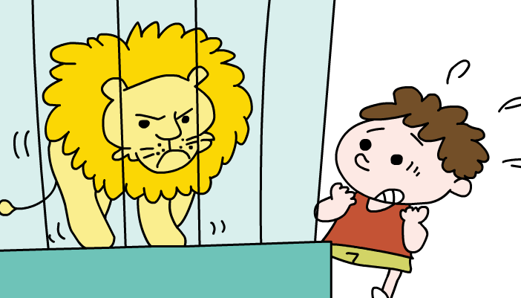 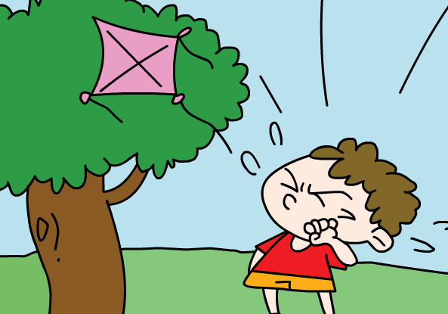
（ ） （ ） （ ） （ ）
3. 4. 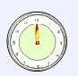 
（ ） （ ） （ ） （ ）
5.  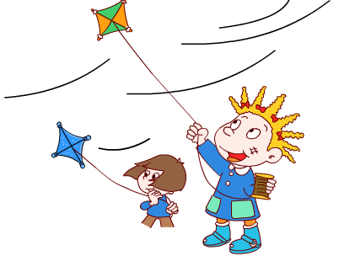
（ ） （ ）
III. Listen and choose. (听问句选择合适的答语) (10%)
( )1. A. They are 10 dollars.
B. There are 4.
C. It's ten ..
( )2. A. It's sunny.
B. It's going to be windy.
C. It rained.

( )3. A. The football team.
B. They go to the zoo.
C. They went to the station.
( )4. A. Yes, I bought a book.
B. No , we didn't .
C. Yes, I bought him a pen.
( )5. A. Last September.
B. Next month.
C. I go there every day.
IV. Listen and judge.（请根据短文内容判断句子是否与短文内容相符，相符的用“√”表示,反之则用“X”表示）(10%)
( )1. Daming will say ‘Happy birthday!’ to Simon.
( )2. Simon’s present will be a birthday card.
( )3. Mum is going to the bookstore and buy a book.
( )4. Daming will get a special present from Simon’s mother.
( )5. They can eat oranges today.
V. Listen and complete the sentences. （听录音，填上所缺单词，补全句子）(10%)
Today is Daming’s birthday. He is ______ a birthday_____ .
His family and new friends _______ there.
Now Daming is playing his______ , but then the telephone ____.
He stops and everyone waits.Then he starts again.
He is playing his _____ song and everyone _______ and ______. But then more friends _______. Everyone _____hello to them.

听力原文：
一．Listen and choose.
1. The sky says “ Happy birhtday.”
2.I want to eat a sandwich,please.
3. Here's your present.
4. He is playing the trumpet,but then the telephone rings.
5. There was a big lake in the park.
6. Tomorrow it’s going to be sunny in Qingdao.
7. They're going to buy things at the supermarket.
8. In this photo, the sun is shining.
9. Simon is making a birthday card.
10. How much are these hot dogs?
They are thirty dollars.
二．Listen and tick.
1.I can’t carry them all.We will help you. Thank you.
2. What did he do? He flew a kite in the park.
3. What a mess! All the balloons are flying away.
4. When are they going to eat ? At twelve o’clock.
5. It's rainy(raining) .
The children are jumping in the water.
三．Listen and choose.
1. How much are the oranges ?
2. What was the weather like yesterday?
3. Where did Mum and Daming go ?
4. Did you buy him a pencil?
5. When are you going to go to the school?
四．Listen and judge.
Module4 Unit1
五．Listen and complete the sentences.
1.having,
2. party,
3.are,
4.trumpet,
5.rings,
6.favourite,
7.listening ,
8.clapping,
9.arrive,
1o.says

