青岛金门路小学2011-2012学年度第一学期五年级英语单元闯关题（时间：40分钟）

Listening Part 听力部分
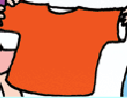
Ⅰ. Listen and tick. 听音选图，在图下的括号里划‘√’表示。(10%)

1．
( ) ( )
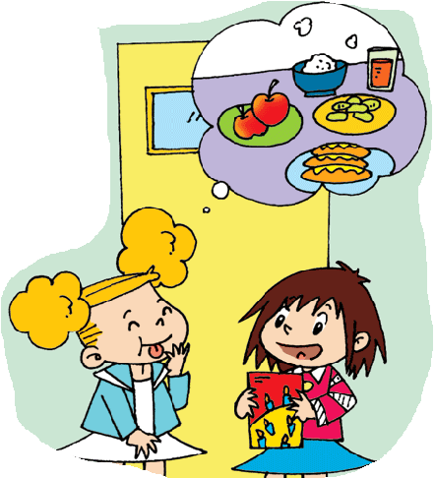
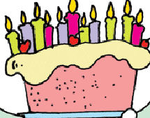
2.
( ) ( )
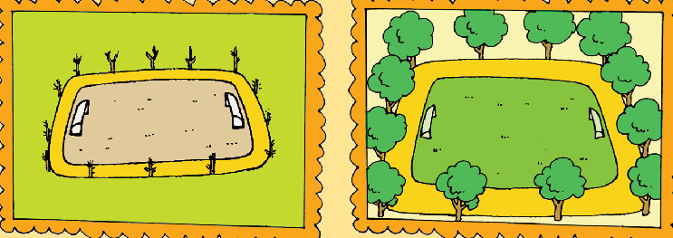
3.

( ) ( )
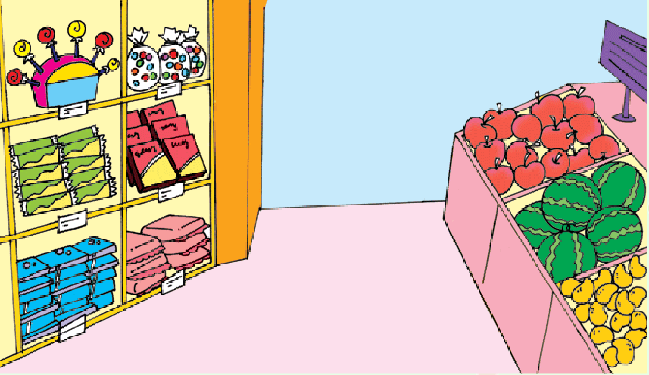
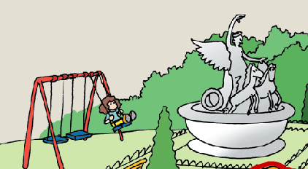

( ) ( )
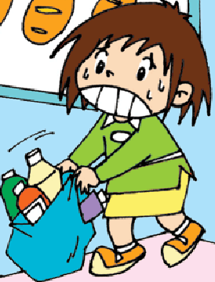

( ) ( )
Ⅱ. Listen and choose. 听问句，选答语。(10%)
( )1. A. It’s his.
B. It’s her skirt.
C. Sam wants to wear it.
( )2. A. Easter.
B. New Year.
C. Halloween.
( )3. A.He’s singing and dancing.
B. He’s going to sing and dance.
C.He’s going to finish his homework.
( )4. A. I will go swimming.
B. I watched TV.
C. I’m reading a newspaper.
( )5. A. Yes, you can.
B. No, thank you.
C. Please help me.
Ⅲ. Listen and write. 听录音，填上所缺单词，补全句子。(10%)
- The film is ___________ __________.
- There are ________ _________ ,too.
3. There weren’t any _________ here _________.
4. We’re _________to have _________ together.
5. This _____ is ___________.
Ⅳ. Listen and circle. 听短文圈出你听到的单词。(10%)
Look at the photo of my ( English / England ) friend, Amy. She’s wearing a beautiful Easter ( cap / hat ). There are toy ( chicks / rabbits ) and ( trees / flowers ) on it. Do you know ( Halloween / Easter )? It’s in ( spring / winter ) . People usually ( giving / give )children chocolate ( egg / eggs) . Some eggs are big ( or / and ) some are small. ( Children / They ) like them a lot.
V. Listen and draw ‘√’or ‘X’.(听一听，画对号错号。) (10%)
( )1. Amy is going to be seven.
( )2. She is going to have a party.
( )3. Lingling is going to go to the party.
( )4. Sam and Daming are going to play with Amy’s new toys.

( )5 .Children are going to help Ms Smart.

Writing Part 笔答部分
Ⅵ. Reorder the words and write. 按照书写要求，用正确规范的形式抄写句子。（10%）
1. is / one / there / now

2. are / trees / there / tall / many

3. go/ they/ to/ houses/ people’s

4. blue dress / is / Amy’s /wet

5. the / scare / people / they

Ⅶ. Look and write. 看图补全句子， 每空填一个单词。（10%）
1. There _________ _________ in 
the supermarket.
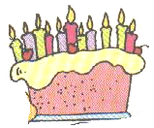
2.--Are you going to ______ a cake?
-- Yes, I am.


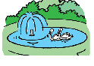
3. There’s a _______ and a ________
in the park.
4. Halloween is an _________ __________..

5. Is it your _________? 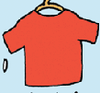
No,it isn’t ___________.
Ⅷ. Read and choose. 读一读，选出最佳的词，将字母标号填在题前的括号里。（10%）
( )1. -Whose jacket is it?
-It’s _______ . _______ is on the line.
A.Susan’s ….Mine B.Susan …My
C.Susan’s ….My
( ) 2. We _______ feed the ducks now.
A. could B. couldn’t C. can
( ) 3. -Are there ________ supermarkets here?
-Yes, there is ________ supermarket.
A. some…a B. any...some C. any…a
( ) 4. There ____ two parks in 2000. Now there ____ four.
A. was…are B. were…were C. were…are
( ) 5. -What are you going to do tomorrow?
-We’re going to ____ .
A. played basketball B. playing basketball
C. play basketball
Ⅸ. Read and judge. 阅读短文，判断句子是否符合短文意思，符合的在括号里划√表示，不符合的划х表示。（5%）
Many English supermarkets are very big. They sell different things. They sell food from lots of countries. They also sell clothes, toys and CDs.
Sometimes there are restaurants at the supermarket.
Many families go to the supermarket together.
( )1. All English supermarkets are very big.
( )2. They only sell Chinese food.
( )3. You can’t find any T-shirts in the supermarket.
( )4. Many families go shopping together.
( )5. .If you are hungry, you can eat at the supermarket..

Ⅹ. Read and choose. 读短文，选择最佳答案，将其前面的字母标号填在题前的括号里。（10%）
Spring festival is coming,Daming’s families are going to their hometown(故乡).It looks different now.There were only small houses before.Now there are some tall buildings(楼房).There were many bikes on the road.Now they can see lots of cars.There are supermarkets and bookstores ,too.They are going to the supermarket.What a big supermarket!They are going to buy vegetbles to make lunch at home.
( )1.Daming’s hometown looks__________ now.
- different B. difficult
( )2.There were _________ in his hometown.
A.bikes B. cars
( )3.There were ________ in his hometown before.
- small houses B. big buildings
( )4. The supermarket is very _________ .
A. big B. tall
( )5. They are going to have lunch ________ .
A. in the supermarket B. at home

Ⅺ. Composition.（小作文）
周末快到了，What are you going to do this weekend?请写一写你的周末计划。
要求语句通顺，内容不少于5句话。（5%）

_________________________________________________________
_________________________________________________________
_________________________________________________________
_________________________________________________________
_________________________________________________________

