青岛金门路小学2010-2011学年度第一学期四年级英语阶段检测
Name______________Class______________Degree______________听力部分
Ⅰ. Listen and number.(请根据听到的内容为下列图片排序。) 10’



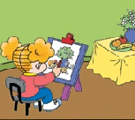
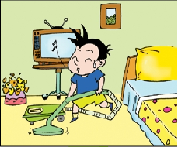

( ) ( ) ( ) ( ) ( )

Ⅱ.Listen and tick.(听音找出相应的图片，并在括号里画“√” 表示。)10’

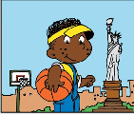

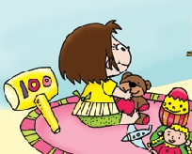
1. 2.

( ) ( ) ( ) ( )
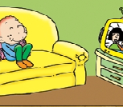
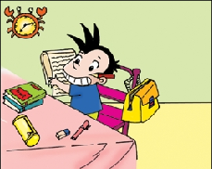
3. 4.

( ) ( ) ( ) ( )
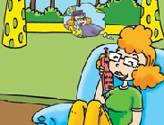
5.

( ) ( )

Ⅲ. Listen and match.（请根据听到的内容将人物与相应图片连线。）10’






Sam Amy Daming Lingling Fangfang

phoned Grandma painted a picture played football

played the flute listened to music

Ⅳ.Listen and fill in the blanks.（请根据听到的内容填上缺少的单词。）10’

1. She _______ in London.
2. Yesterday, I ___________ my room.
3. I ____________ this newspaper.
4. She didn’t _________ English.
5. Then Daming _________ his mum.

Ⅴ. Listen and put the words in the right order.（听音连词成句。）12’

1. at half past six / didn’t / get up / Lingling

2. at / were / Buckingham Palace / we

3. live / where / she / does

4. invented / Chinese / paper/ people

5. I / my / trousers / washed

6. and / didn’t / she / school / walk to

Ⅵ.Listen and circle.（请根据听到的内容圈出正确答案前的标号。）8’
1. 1)Where does Lucy live?
A. She lives in London. B. She lives in Beiing.
2) Did Mr Smart cook noodles yesterday?
A. Yes, he did. B. No, he didn’t.

2. 1)What did Lingling do yesterday?
A. She learned English and Maths. B. She watched TV.
2)Who invented this bicycle in 1839?
A. An American invented this bicycle.
B. An English invented this bicycle

笔答部分

Ⅶ.Read and match.（读一读, 连一连。）8’

I stayed at home and played with my toys.

Lingling didn’t learn English and Maths.
Because yesterday was National Day!


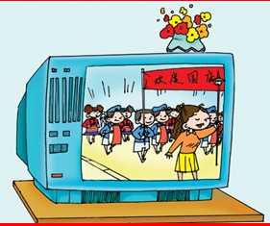
John is from America. He likes playing
Basketball.

Yesterday Daming didn’t play football.
He helped his mum.

Ⅷ.Read and choose. （读一读,选一选。）10’
( ) 1. Yesterday, she _______ buy a present.
A. don’t B. didn’t
( ) 2. _________ does he live? He lives in Qingdao.
A. Where B. What
( ) 3. Amy usually _________ at seven o’clock.
A. gets up B. get up
( ) 4. She didn’t _________ her homework yesterday.
A. finished B. finish
( )5. What did you do yesterday? I _________ a picture.
A. paint B. painted

Ⅸ.Read，choose and write.（读一读,选择单词补全这封信。）12’
stayed was usually played walk didn’t

On Mondays, Lucy ___________ walks to school. But she didn’t ________ to school yesterday. And she _________learn Maths. Yesterday_______ National Day. She __________at home and ___________ with her toys.

Ⅹ.Read and draw“√”or “× ” （读一读,判断句子是否符合短文大意,如符合用“√”表示,反之用“× ” 表示。）10’
Yesterday was Saturday. Daming and Sam played basketball. Amy and Lingling washed their trousers. Mom cooked noodles. Dad watched TV. They had a good time.
( ) 1. Yesterday was Sunday.
( ) 2. Daming played football.
( ) 3. Amy cooked noodles.
( ) 4. Dad watched TV.
( ) 5. They are not happy.

Ⅰ. Listen and number.(请根据听到的内容为下列图片排序。) 10’
1. Yesterday, Mr. Smart cooked noodles.
2. Daming washed his trousers last Sunday.
3. Amy painted a picture last night.
4. Yesterday, Daming cleaned his room.
5. Last Saturday, Daming helped his mum.
Ⅱ.Listen and tick.(请根据听到的内容找出相应的图片，并在括号里画“√” 表示。)10’
1. Lingling didn’t walk to school yesterday.
2. Where does she live? She lives in London.
3. What did you do yesterday? I painted a picture.
4. Did you help your dad yesterday? No,I watched TV.
5. Last Wednesday was National day. My mum phoned my grandma.
Ⅲ. Listen and match.（请根据听到的内容将人物与相应词组连线。）10’
Yesterday was Sunday. Fangfang played the flute. Sam played football. Amy phoned Grandma . Linging didn’t ride the bike. She listened to music. And Daming painted a picture. It was a fun day, everyone was happy.
Ⅳ.Listen and fill in the blanks.（请根据听到的内容填上缺少的单词。）10
1. Chinese people invented _paper__.
2. Yesterday, we ___cleaned__my room.
3. I printed this newspaper.
4. She didn’t __learn__ English.
5. We __ate__ biscuits and apples.
Ⅴ. Listen and put the words in the right order.（听音连词成句。）12
1. Lingling didn’t get up at half past six.
2. We saw lots of mountains.
3. Chinese people invented paper.
4. Then I helped my mom.
5. Where does she live?
6. We had a good time.
Ⅵ.Listen and circle.（请根据听到的内容圈出正确答案前的标号。）8
- Hello everyone! This is my friend Lucy. She lives in London. I’m reading her letter. She is very nice. I like her.
- Yesterday Mr Smart cleaned the room. And he cooked noodles, too.
3. Lingling didn’t go to school yesterday. She watched TV and played with her toys.
4. Look at this bicycle. He was an English. He invented this bicycle in 1839.

