2009-2010学年度第一学期五年级英语期末练习题（二）
Name:_______ Class:______ School:________ Assessment:______

Listening Part 听力部分
Ⅰ. Listen and tick. 听音选图，在图下的括号里划‘√’表示。(10%)


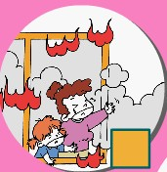


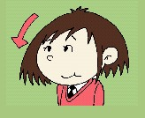

1． 2. 3.

( ) ( ) ( ) ( ) ( ) ( )

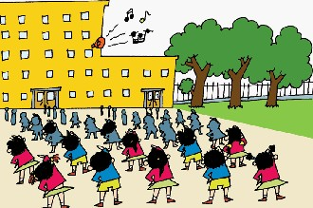
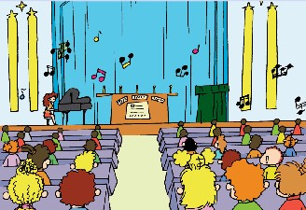
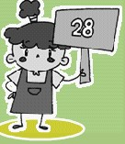
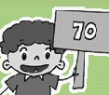
- 5.

( ) ( ) ( ) ( )
Ⅱ. Listen and choose. 听问句，选答语。(10%)
( )1. | A. Not very well. | ( )2. | A. I get up at 7o’clock.
 | B.No, thank you. |  | B. I finished my homework.
 | C. Please help me. |  | C. I’m reading a newspaper.
( )3. | A. Yes, I can. | ( )4. | A. Not at all.
 | B. No, they can’t. |  | B. You’re welcom.
 | C. Yes, it does. |  | C. Thanks.
( )5. | A. I’m thingking.
 | B. No， I am not.
 | C. Yes， I am.
Ⅲ. Listen and write. 听录音，填上所缺单词，补全句子。(10%)
- You can__________ basketball __________.
- This dog can __________ ___________.
- In England， they ___________ around__________.
- You ________ play _________ the CDs.
- There are________ ________ games.
Ⅳ. Listen and circle. 听短文圈出你听到的单词。(10%)
Yesterday，it was (rain / raining), Zara couldn’t( go / went ) out . She was (happy / sad ) .She helped her mum make a ( cake/ flower).
After that， she was ( hungry / thirsty ). She ( eat/ ate ) the cake with Mum. She was very thirsty. She drank ( any / some) water.
( Then/So)the rain ( stopped / stop ) .Zara went out to ( play/ played). Then Zara was happy.
V. Listen and choose. 听短文回答问题，选择正确答案。 (10%)
( ) 1. When is Christmas?
A. In autumn. B. In spring. C. In Winter.
( )2. Is Lingling sad?
A. No, she isn’t. B. Yes, she is. C.Nothing.
( )3. Does Lingling want to play chess?
A. No, she doesn’t. B. Yes,she does. C. She is bored.
( )4. What is the matter with Lingling?
A. Yes, she is. B. No, she is not. C. It’s a secret.
( )5. Is it a secret now?
A. It’s not a surprise. B. They are small. C. No, it is not.

Writing Part 笔答部分
Ⅵ. Reorder the words and write. 按照书写要求，用正确规范的形式抄写句子。（10%）
1. there/ a lake/ wasn’t/ here

2. can / run /fast/you

3. he/wants/to/only/paly

4. they/ songs /sing/ together/every /morning

5. time/ what /do /you/up/get

Ⅶ. Look and write. 看图补全句子， 每空填一个单词。（10%）
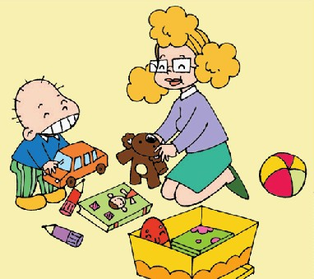
1. You shoud ________ your ________.


2. –Can Feifi help the ________ _______?
---No，he can’t.

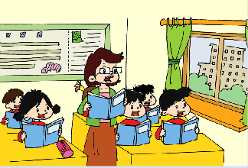
3. We _______ in ________in China.
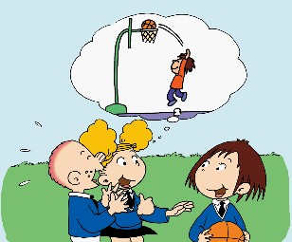
4. You can ________ ________
.

5. Sam： Whose ________is it？
Lingling：It’s ________.
Ⅷ. Read and choose. 读一读，选出最佳的词，将字母标号填在题前的括号里。（10%）
( )1. What time do you have English class？I have English class ________9 o’clock.
A. in B. on C.at
( ) 2. What are you doing ？ I am---------- basketball.
A. play B. playing C. plays
( ) 3. Here’s ________ invitation to my party.
A. a B. an C. /
( ) 4. There ____ two parks in 1997. Now there ____ four.
A. was, are B. were, were C. were, are
( )5. Are these pencils yours？ Yes，they are-----------.
A.me B.my C. mine
Ⅸ. Read and judge. 阅读短文，判断句子是否符合短文意思，符合的在括号里划√表示，不符合的划х表示。（5%）
This is an English school .There are children’s paintings on all the walls .There are lots of games . English children can have fun at break time. They study hard . They do homework every day .
( )1. | This school is in England .
( )2. | There are children’s photos on all the walls .
( )3. | They can play games at break time .
( )4. | English children don’t do homework every day .
( )5. | They have fun every day ,so they don’t study hard.

Ⅹ. Listen and choose. 读短文，选择最佳答案，将其前面的字母标号填在题前的括号里。（10%）
Last Saturday, it was sunny in the morning . I went to the park with my friends .We saw lots of flowers .We took photos .At lunch time ,we were very hungry and thirsty .So we ate cakes and drank some water . After that ,we played games on the grass . A man came to us and said, “Don’t play on the grass ! You should play outside . ” So we went out of the grass and played ball games .Then we were very tired .It was three o’clock .We couldn’t stay at the park .We went home by bus .When we got home , it rained. Oh, my God !We were so lucky(幸运的)!
( )1. It was on Saturday morning .
A. sunny B. rainy C. snowy
( )2. We at the park .
A. took photos B. played ball games C. A and B
( )3. We play on the grass .
A. could B. should C. shouldn’t
( )4. ---- What was the matter with them after the ball games ?
-----They were very .
A.tired B. hungry C. thirsty
( )5.We were lucky because .
A.we played on the grass
B. we didn’t get wet in the rain
C. we ate the cakes and drank some water

Ⅺ. Composition. 以上描述了一位同学上周六的经历，请你仿照短文，写一写你上个周六是怎样度过的，要求语句通顺，内容不少于5句话。（5%）
________________________________________________________ _
________________________________________________________ _
______________________________________________________ ___
_____________________________________________________ ____
________________________________________________________ _

录音内容Listening Part 听力部分
Ⅰ. Listen and tick. 听音选图，在图下的括号里划‘√’表示。(10%)
- It found the people.
- The elephant can play football.
- Lingling can’t run fast.
- We do morning exercises in China.
- He got seventy points. He is won.
Ⅱ. Listen and choose. 听问句，选答语。(10%)
- Can you catch the ball?
- What time do you get up?
- Does Amy go to school at 9 o’clock?
- Thanks for your help.
- What’s the matter, Lingling?
Ⅲ. Listen and write. 听录音，填上所缺单词，补全句子。(10%)
- You can_play_______ basketball _well_.
- This dog can help him.
- In England， they sit around tables.
- You shouldn’t play with the CDs.
- There are_lots _ of games.
Ⅳ. Listen and circle. 听短文圈出你听到的单词。(10%)
Yesterday，it was (rain / raining), Zara couldn’t( go / went ). She was (happy / sad ) .She helped her mum make a ( cake/ flower).
After that， she was ( hungry / thirsty ). She ( eat/ ate ) the cake with Mum. She was very thirsty. She drank ( any / some) water.
( Then/So)the rain ( stopped / stop ) .Zara went out to ( play/ played). Then Zara was happy.

