2009—2010学年度第一学期五年级英语综合练习题(四)
学校_________________ 班级_________________ 姓名_________________

密 封 线
（时间：40分钟 总分:100分）

Listening Part 听力部分
Ⅰ.Listen and choose. 请选出你所听到的单词或词组，并将其前面的字母标号填在题前的括号里。（10分）
( )1. A. pond | B. river | C. lake | D. sea
( )2. A. help | B. talk | C. scare | D. send
( )3. A. fifty | B. forty | C. sixty | D. seventy
( )4. A. angry | B. tired | C. bored | D. hungry
( )5. A. his | B. yours | C. hers | D. mine
( )6. A. be late | B. be kind | C. try hard | D. be nice
( )7. A. fruits and hamburgers |  | B. sweets and fruits
C. sweets and vegetables |  | D. fish and sweets
( )8. A. open the door |  | B. hear people
C. find people D. play with a ball
( )9. A. do homework B. read books
C. draw pictures D. row a boat
( )10. A. big school B. big playground
C. small school D. small playground
Ⅱ. Listen and number. 根据听到的内容给图片排序(10分)
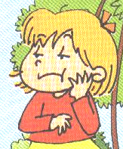
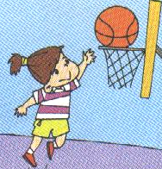
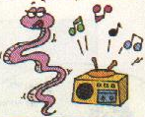

（ ） （ ） （ ）
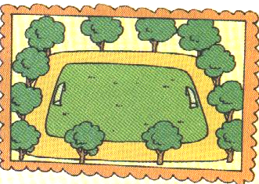
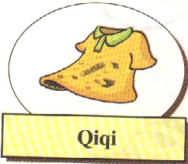

（ ） （ ）
Ⅲ. Listen and judge. 听一听，判断听到的内容与所给的图片是否一致，并用“√”或“×”表示。（10分）
1. 2. 3.
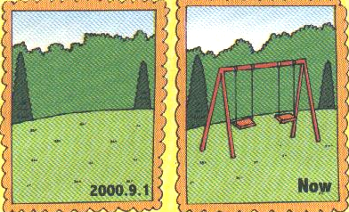
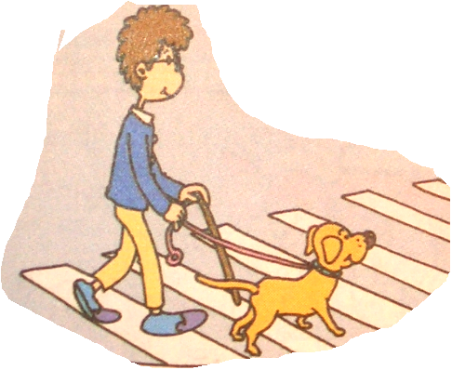
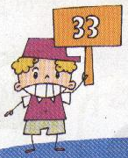

（ ） （ ） （ ）
4. 5.
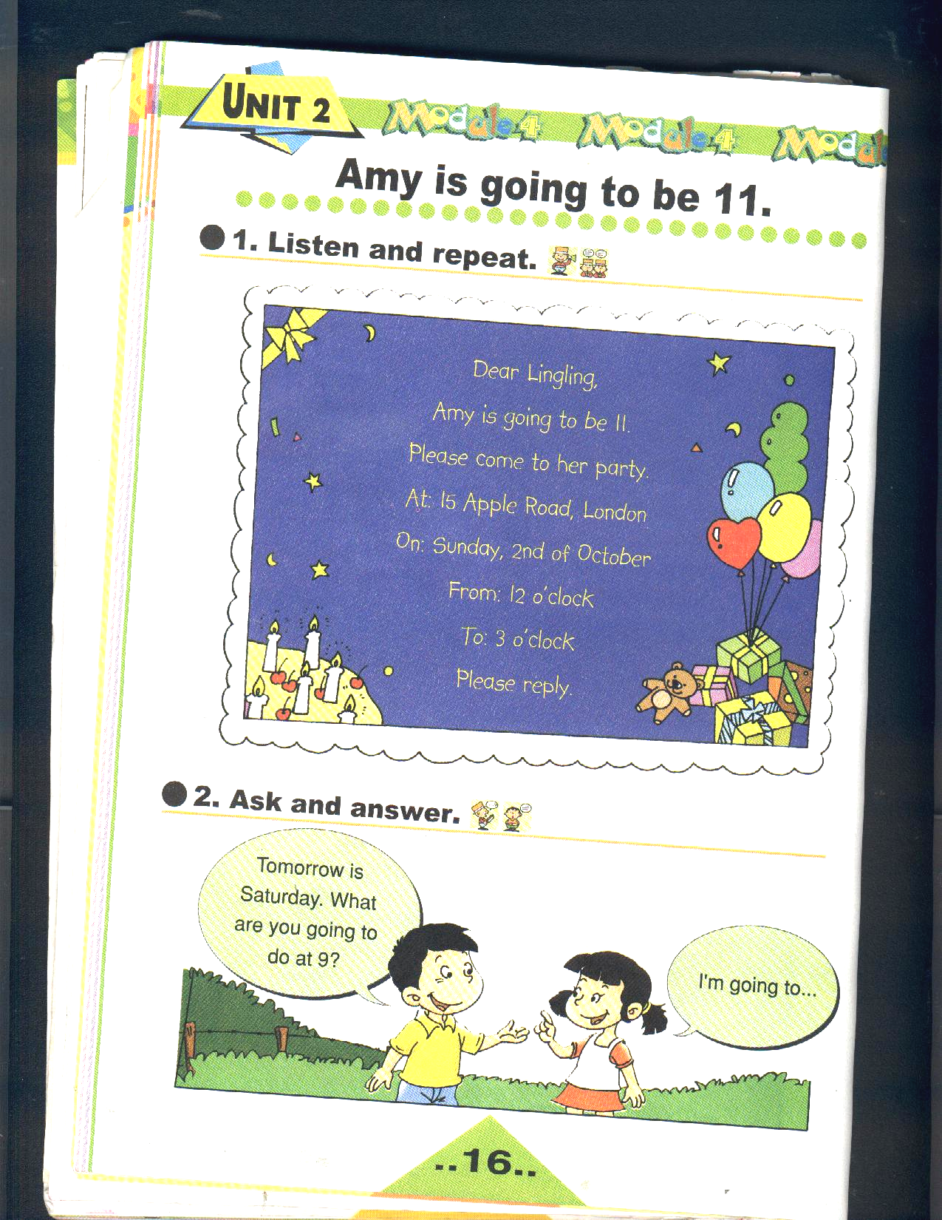
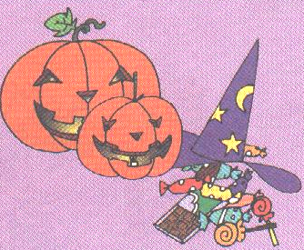

（ ） （ ）
Ⅳ. Listen and choose. 根据听到的内容回答问题，并圈出正确答案前的字母标号。（8分）
i. 1. What’s the weather like ?
  - It’s snowing. B. It’s raining. C. It’s sunny.
- What colour is Amy’s dress?
A. It’s red. B. It’s green. C. It’s blue.
3. Are Sam’s shoes dirty?
A. Yes, they are . B. No, they aren’t. C. Yes, it is.
4. What are the children doing?
A. They’re playing at home.
B. They’re doing homework
C. They’re running home.
ii. 1. Where was Sam yesterday?
A. He was at home. B. He was at school
C. He was at Daming’s flat.
2. Did Sam play ball games?
A. Yes, he did. B. No, he didn’t . C. No, he played football.
3. Did Sam and Daming clean the room?
A. Yes, they did. B. No, they didn’t.
C. No, Daming went home.
4. What did they eat?
A. They ate some rice. B. They ate some noodles.
C. They ate some fruit.
Ⅴ. Listen and complete the sentences. 听录音，填上所缺单词，补全句子。(10分)

1. Halloween is an festival. Easter is in .
2. This dog can help the .
3. This supermarket is very big. It , toys
and CDs.
4. -- Can she jump ?
-- Yes, and she can run too.
5. She was thirsty. She some .

Writing Part 笔答部分
Ⅵ. Read and choose . （读一读，将正确答案前的字母标号写在相应的横线上。） (6分)
1．There five ducks before. There was only one.
A. weren’t B. was C. are
2. Sam is going to with the new toy this afternoon.
A. plays B. play C. playing
3. -- kite is it? -- It’s Feifei’s.
A. Whose B. Who C. Where
4. How many Mondays are there this January?
A. at B. in C. on
5. This is my hat. It’s .
A. I B. my C. mine
6. I was three then. I couldn’t .
A. swim B. swimming C. swims

Ⅶ. Put the words in the right order. 连词成句，按照书写要求，用正确规范的形式写出下列句子。 (10分)
1. go / they / houses / to / people’s

2. are / many / sweets / there

3. could / the / it / people/ hear

4 . can / play / well / you / football

Ⅷ. Look and write. 看图补句子，每空填一个单词。
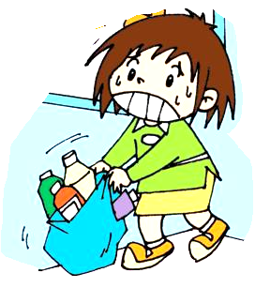
( 8分)
1. This bag is .
I can’t lift it.
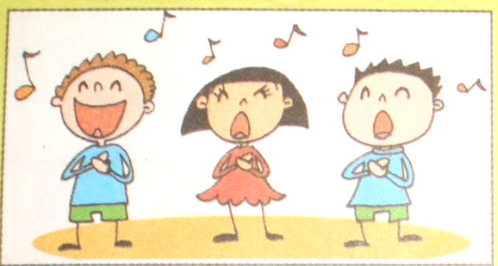
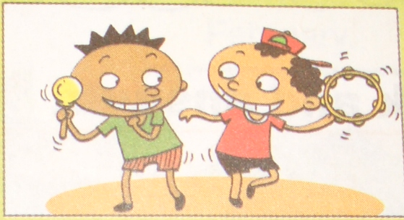
2. --What are you going to do at the party?
--We’re going to and .
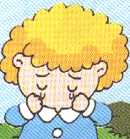
3. --Is she ?
--Yes, she .
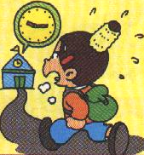
4. You shouldn’t be .


5. --Are you going to have a
?
-- Yes, I am.

Ⅸ. Look, choose and write. 看一看，选一选，将月份按照顺序填入相应的方框。（6分）
May December March July December October

January February April June
August November

Ⅹ. Read and judge. 读一读，作判断，并用“√”或“×”表示。（8分）
Laura: Did you go out with Sam?
Ben: Yes, I did. We went out on Sunday afternoon. We
bought the new Harry Potter book.
Laura: Did you like it?
Ben: I liked it a lot. But Sam didn’t.
Laura: Oh, well. What did you do after that?
Ben: We went swimming together.
Laura: Did you have fun?
Ben: Yes, we did. We had a great time. And we’re going to go
out again next week.
1. Ben went out with Laura on Sunday. ( )
2. Ben and Sam liked the Harry Potter book very much. ( )
3. Ben and Sam went swimming together. ( )
4. Ben is going to go out with Sam next week. ( )

Ⅺ. Read and answer. 读一读，回答问题。（8分）
My name’s John. Tomorrow is Saturday. We have no classes.
My parents (父母) aren’t going to work. But we’re going to have a busy(繁忙的) day. My mother is going to go to the supermarket. She is going to buy some food. My father is going to wash his car. I’m going to play the piano. On Saturday evening (晚上) we’re going to see a film. I think (想，认为) we are going to have a nice day.
- Is John’s father going to work tomorrow?

2. Where is John’s mother going ?
She’s going to
- What is John’s father going to do?
He’s going to
- What are they going to do on Saturday evening?
They’re going to
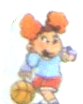
Ⅻ. Try to complete the passage according to the pictures. 请根据图片的内容，补全下面的短文。 (6分)
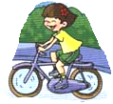
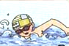
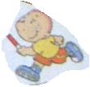
Tom Mary Sam Amy
My name’s Amy. I’ve got three friends. They’re Tom, Mary and Sam. We all like sports. Tom can swim well.

We play together at the weekend. And we always have fun!

