2009--2010学年度第一学期期末五年级英语练习题（四）

（时间：40分钟 满分：100分）

Listening Part 听力部分
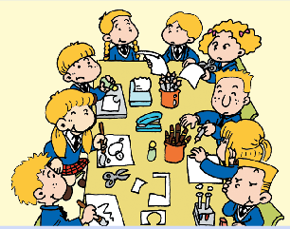
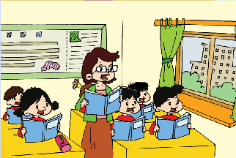
Ⅰ. Listen and tick. 听录音，在相应图片下面的括号里画“√”表示。(10%)
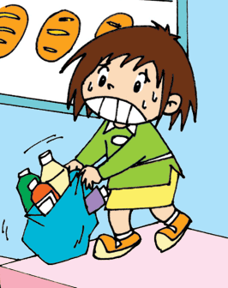

1． 2.

( ) ( ) ( ) ( )


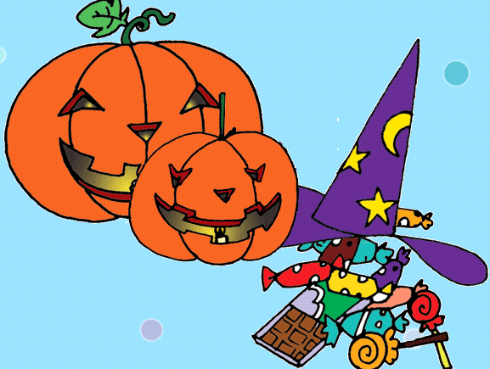

3. 4.

( ) ( ) ( ) ( )
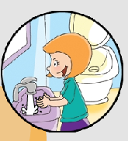

5.

( ) ( )
Ⅱ. Listen and choose. 听问句，选答语。(10%)
( )1. | A. We are going to sing songs.
 | B. We made an English newspaper.
 | C. They made a birthday cake for Zara.
( )2. | A. This bag is heavy.
 | B. Sorry, I can’t lift the bag.
 | C. There were twenty books in the bag.
( )3. | A. Yes, she can.
 | B. Yes, she could.
 | C. Yes, she did.
( )4. | A. The shop starts at 8 o’clock every morning.
 | B. The shop is going to start at half past 8.
 | C. Yes, the shop will start at 8 next week.
( )5. | A. This new dress is mine.
 | B. Yes, the nice one is hers.
 | C. No, Amy’s dress is wet.
Ⅲ. Listen and write. 听录音，填上所缺单词，补全句子。(10%)
1. They go to _________ __________.
2. In class, we ____________ __________ each other.
3. Come on! You can _______ _________.
4. My God! Tom is ________ a _________.
5. Can the _________ dog _________ the baby in fire?
Yes, it is very clever!
Ⅳ. Listen and circle. 听短文，圈出听到的单词。(10%)
Dear Daming:
Amy’s birthday _________ (is, will) coming. I _______(wanted, wants) to _________ （give, giving） her a big surprise present a few days ago.
. As you know, Amy is a lovely girl. She likes sports. She is ________(well, good) at PE. She ____( couldn’t, can’t) run fast before. But she _________ (did, does) morning exercises everyday. Now she _______(is, was) the racing winner in our class. She ___________(couldn’t, shouldn’t）play basketball before. But she catches the ball very ___________（well, good）now. What ________(should, am) I prepare for her birthday? A new basketball or a new baseball cap?
Respect soon.
From,
Lingling
V. Listen and judge “True”or “Fause”. 听短文，根据短文内容判断,用“T”或“F”表示。 (10%)
( ）1 Yesterday, there was a football game in the park.
( ) 2 Sam’s team got forty points.
( )3 Sam got seventeen points.
( ) 4 Amy got thirty points.
( ) 5 Sam’s team won the game. They were happy.

Writing Part 笔答部分
Ⅵ. Reorder the words and write. 将所给单词组成句子，按照书写要求，用正确规范的形式写在四线格中。（10%）
1. you/ take/ off/ the/ shelves/ the/ books/ should

2 many/ dog/ special/ a/ blind/ England/ in/ people/ have
.
3. what/ matter/ the/ is/ Amy

4. children/ around/ sit/ the/ tables/ England/ in

5. Amy's/ wet/ is/ dress/ blue

Ⅶ. Look and write. 看图补全句子， 每空填一个单词。（10%）

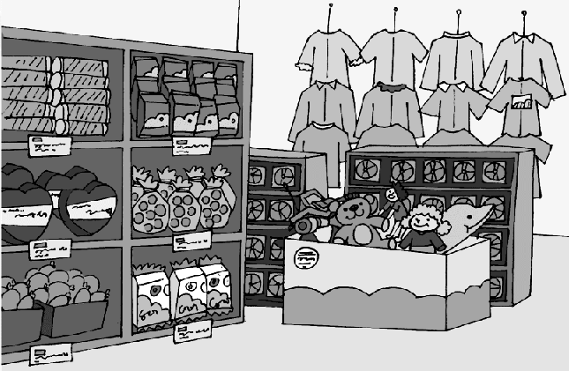
- Many supermarkets ________ different
things. There are _______ of things from
different countries.
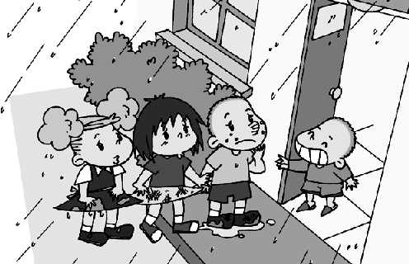
2. Children are _________home.
Their clothes are ________ now!

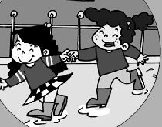
3. At last, Zara ________ out to play.
And she was very _________.
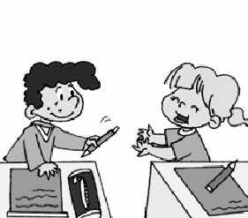
4. You should be _________ and __________.

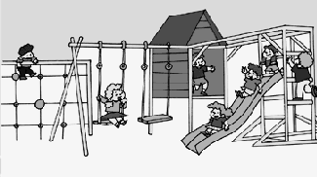
5. English children can __________fun
at ________time.

Ⅷ. Read and choose. 读一读，选出最佳答案，将其前面的字母标号填在题前的括号里。（10%）
( ) 1.You ________ eat some fresh fruits.
A. are B. should C. wasn’t
( ) 2. She only wants to use _______ pen.
A. her B. mine C. Mike

( )3. I didn't ______ a hundred points.
A. got B. get C. gets

( )4. There _____ children inside the room.
A. was B. were C. is

( )5. Be careful! The bus is coming!
Oh!__________
A. Thanks a lot! B. Not at all. C. Wonderful!
Ⅸ. Read and judge. 读短文，判断句子是否符合短文意思，符合的在括号里划“√”表示，不符合的划“×”表示。（5%）
January 1st is New Year's Day. It's a great day for all the people around the world. As the saying goes, "A good beginning is half the battle". So, many people go all out to celebrate the important day. On that day, I went to the Book City with my classmates. We bought a lot of useful books and interesting story books. I bought an art book, two English books and two science books. I believe "Knowledge is power". I hope I can learn a lot from these books and improve my study. In the evening, my family had a big dinner party. I got a nice pen from my parents. All the members in my family wished me a good luck in the new year. I love New Year!
( )1 January 1st is the beginning of a year.
( ) 2 I went to the zoo with my classmates that day.
( ) 3 We bought a lot of books and toys.
( ) 4 I bought five books at last.
( ) 5 My family had a big good dinner together at that night.

Ⅹ. Read and choose.(读对话，选择正确的答案。) (10%)
Qiqi: What do you want, Mum?
Mum: I want to buy noodles, meat, eggs, fish and chicken.
Qiqi: Why, Mum?
Mum: Your dad is going to be forty. Let’s have a party.
Qiqi: Good idea! What are we going to do at the party?
Mum: We’re going to invite your grandparents and have lunch together. We’re going to sing a song to Dad. Also we’re going to give him a present.
Qiqi: Of course! That’s great!

( )1. | What are they doing? They’re _______ .
 | A. playing |  | B. going |  |  |  | C. shopping |  |  | D. eating
( )2. | Mum doesn’t want to buy ________ .
 | A. candy |  | B. fish |  | C. meat |  |  |  | D. chicken
( )3. | Who is going to go to the party?
 | A. grandma |  |  | B. Amy |  |  | C. grandpa |  |  |  | D. A&C
( )4. | What song is Qiqi going to sing?
 | A. Merry Christmas! |  |  |  |  | B. Hi! |  | C. Happy birthday!
( )5. | How old is Dad going to be?
 | A. 40 | B. 45 |  |  | C. 35 |  |  |  | D. 44
- Composition.(小练笔。) (5%)
写一写你的春节计划吧! 要求语句通顺，不少于3句话。
Chinese New Year is coming. What are you going to do?
________________________________________________________________________________________________________________________________________________________________________________________________________________________________________________________________________________________________________________________

