2009-2010学年度第一学期三年级英语期中综合练习(一)
School______ Class ______ Name______ Assessment______
Listening Part 听力部分
Ⅰ. Listen and number. (听一听，排一排)(10%)
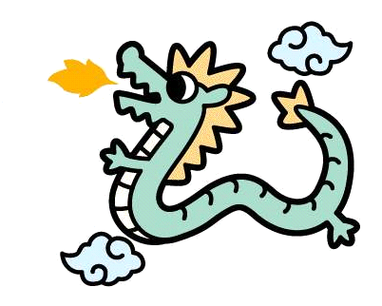


( ) ( ) ( ) ( ) ( )
Ⅱ.Listen and tick. (听一听，选一选。) (12%)
- 2.
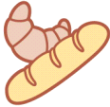

（ ） （ ） ( ) ( )
3. 4.

（ ） （ ） ( ) ( )

5. 6
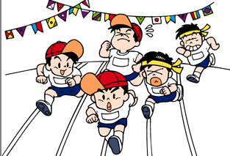

( ) ( ) ( ) ( )

Ⅲ. Listen and judge.（听录音，判断听到的内容是否与图片一致。）（8%）
1. 2. 3. 4.

（ ） （ ） （ ） （ ）
Ⅳ. Listen and match.(听一听，连一连) （10%）
He’s eating an ice-cream.

She can use chopsticks.

He’s writing a letter.

This is her ruler.

Ⅴ. Listen and draw “√”.（请根据听到的内容在相应的表格里画“√”表示。）（10%）

 |  |  |  |  | 
can
can’t

Writing part笔试部分
Ⅵ. Read and number .（按句子顺序给图片标序号）(5%)
1. Can I have a hamburger? Yes.
2. What’s are they doing? They’re singing.
3. Can you eat a boat? No.
4. This bird can’t fly.
5. These are Sam’s trousers.




( ) ( ) ( ) ( ) ( )

Ⅶ. Choose and write.(选择所给单词补全句子) (5%)
fly, listen to music, jump far, use, watching TV, making a cake, running fast

1. This bird can ___________.

2. What are you doing, dad?
I’m ___________.

- We _______ a knife and a fork in England.

- What is Sam doing?
He’s _________.


- Can you _______? Yes.

Ⅸ. Read and copy the sentences.（用正确的形式抄写下列句子。）（5%）
- can , i , have a drink, please

- please, be ,quiet

- but, you ,can, have, some, ice creams

- do, you, use ,chopsticks, in england

- no, you ,can, not

Ⅹ.Read and choose.(阅读理解) (5%)
It is a windy day today. We are at home. Dad is reading newspaper. Mum is making a cake. Amy is ill, she can’t eat ice cream, but she can eat some biscuits. Tom is playing with his train. I’m doing my homework, I can help mum.
- It is a _______ day today. A .sunny B. windy
2. We are at ________. A. at home B. at the park
3. Mum is ________. A. working B .making a cake
4. Tom is playing with his______. A. car B. train
5. Amy is ill , she can________. A. eat biscuits B. eat fast food

Tapescript:
Ⅰ. Listen and number. (听一听，排一排)(10%)
- We use a knife and fork in England.
- Do you want noodles? Yes.
- They are dragons.
- Peter is playing football.
- Can I have some biscuits? Here you are.
Ⅱ.Listen and tick. (听一听，选一选。) (12%)
1.What is he eating? He’s eating bread.
2. This is Amy’s shirt.
3. Is it Fangfang’s plane? Yes, it is.
4. This fish can swim.
5. Can I have a drink, please? Yes.
6.Dick can swim fast.
Ⅲ. Listen and judge.（听录音，判断听到的内容是否与图片一致。）（8%）
Amy can jump far. She is the winner.
- Sam can run fast. He is the winner.
- Taotao can use a knife and fork.
- I like dumplings.
Ⅳ. Listen and match.(听一听，连一连) （10%）
- Hello,I’m Sam. I’m writing a letter.
- I’m Daming . I’m eating an ice cream.
- I’m Amy . I can use chopsticks.
- I’m Lingling. This is my ruler.
V. Module 5 Unit 1

