市南区2009——2010学年度第一学期六年级英语综合练习(十一)（时间：40分钟）

Listening Part 听力部分
Ⅰ. Listen and choose. 选出听到的单词或词组，并将其前面的字母标号填在题前的括号里。（10%）
( )1. A. only | B. also | C. other | D. another
( )2. A. often | B. always | C. nearly | D. usually
( )3. A. line | B. quiet | C. noise | D. loud
( )4. A. said | B. saw | C. says | D. see
( )5. A. hungry | B. thirsty | C. tired | D. excited
( )6. A. important | B. mean | C. fantastic | D. special
( )7. A. suck | B. such | C. sing | D. swing
( )8. A. 18 | B. 8 | C. 80 | D. 8th
( )9. A. elephants | B. rabbits | C. dogs | D. lions
( )10. A. January |  | B. February
C. November |  | D. December

Ⅱ. Listen and tick. 根据录音内容，在相应图片下面的括号里划“√”表示。（10%）



1. 2. 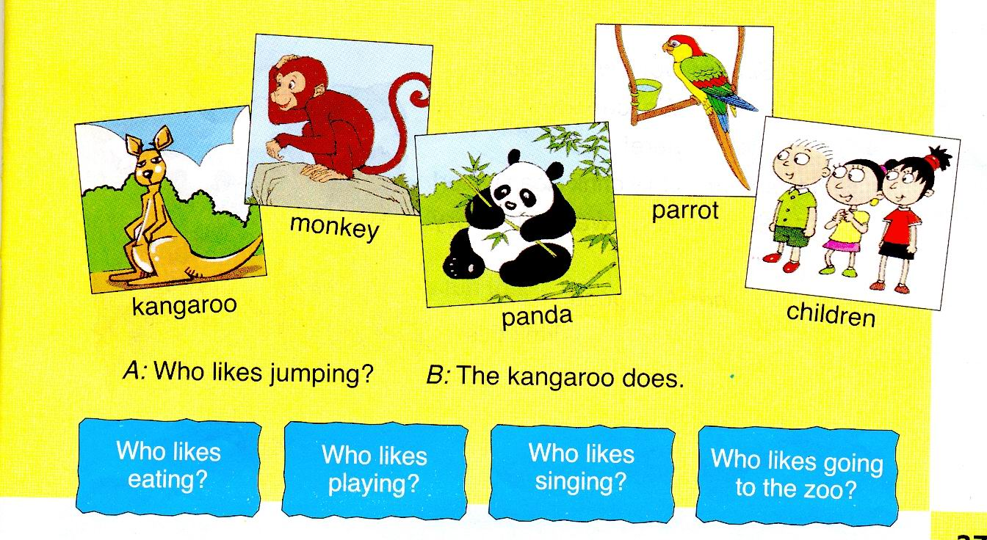
（ ） （ ） （ ） （ ）
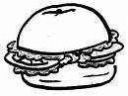
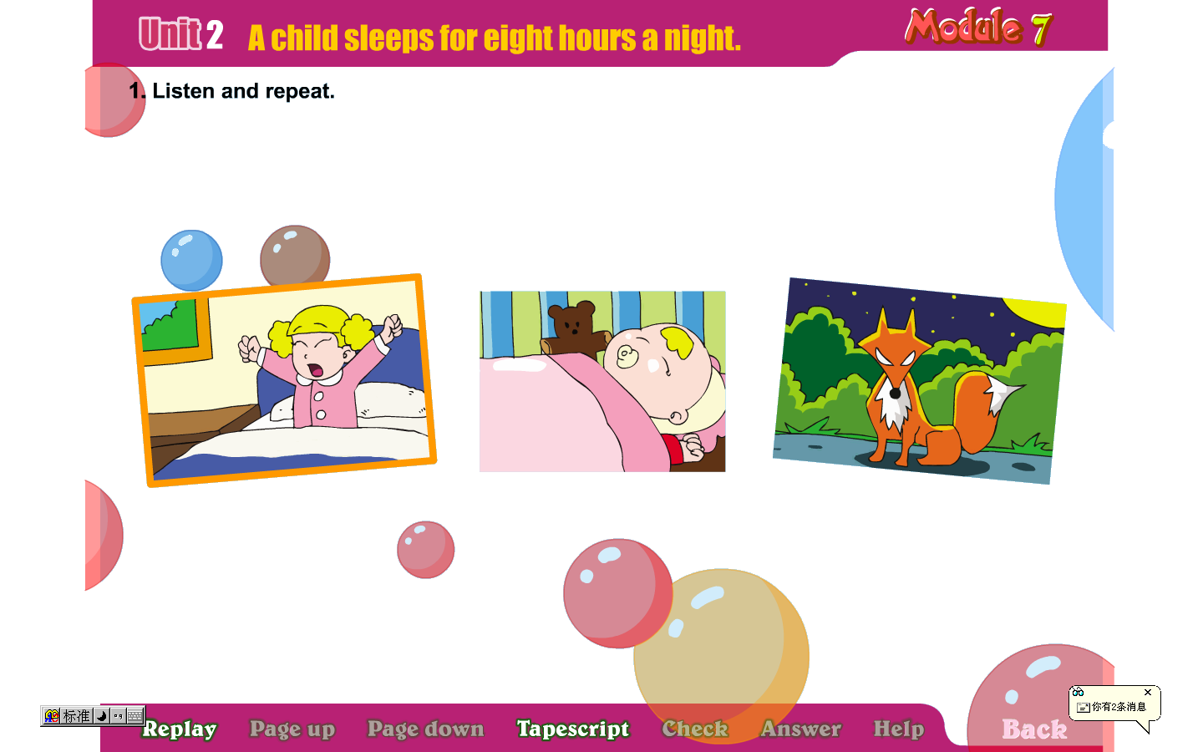

3. 4.
（ ） （ ） （ ） （ ）


5.

（ ） （ ）
Ⅲ. Listen and choose. 听问句，选答语。（10%）
( ) 1. A. I like reading books.
B. I read books everyday.
C. I want to read books.
( ) 2. A. Yes, they love dumplings.
B. Yes, they do.
C. They love them.
( ) 3. A. She lives in China.
B. He lives in China.
C. I live in China.
( ) 4. A. Yes, he has.
B. No, I haven’t.
C. We have got some stamps from China.
( ) 5. A. I’m tidying my room.
B. I often tidy my room.
C. I like tidying my room.
IV．Listen and judge. 听短文，判断句子是否符合短文意思,符合的用“√”表示， 不符合的用“×”表示。（10%）
（ ）1. Daming wants to visit the UN building.
（ ）2. The UN building is in China.
（ ）3. The UN wants to make peace in the world.
（ ）4. The UN building isn’t very tall.
（ ）5. There aren’t any tall buildings in China.
V. Listen and complete. 听录音，补全短文。（10%）
Yesterday was a holiday. We _______ to a park. We _______ there often. We _______ a picnic. Boys ________ thirsty. They ________ water. It tasted good.
Writing Part 笔答部分
- Read and choose. 读一读，选出最佳答案，将其前面的字母标号填在题前的括号里。（10%）
（ ）1. ---__________ is the museum?
--- It’s more than two hundred years old.
A. How long B. How old
C. How often D. How tall
（ ）2. ______ they ______ to the Ming Tombs last Sunday?
A. Do…go B. Did …went
C. Did …go D. Does…go
（ ）3. Here are some stamps _____ America and Canada ____ you.
A. for, for B. from, from C. from, for D. for, from
（ ）4. Christmas ______ every year. It’s ____ the 25th of December.
A. comes, on B. came, in C. come, at D. coming, of
（ ）5. He can speak ______ English, you can write to ______.
A. any, he B. many, his C. a, he D. some, him
（ ）6. ______ Daming and Lingling got ______ stamps?
A. Have, any B. Has, some C. Have, a D. Has, of
（ ）7. --- ______ does it sleep?
--- It sleeps for 4 hours a day.
A. How many B. How long
C. How much D. How often
（ ）8. Do you often ______ your thumb?
A. sucking B. suck C. stopping D. stop
（ ）9. The countries of the UN ____ to bring peace to the world.
A. want B. wants C. went D. won’t
（ ）10. The students sit around the tables in England. We sit ______ in China.
A. in lines B. in a line C. on line D. at line

- Look and write. 看图补全句子，每空填一个单词。（10%）
- It’s a ________ of Hainan island.
（图片）
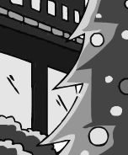
- What can you see?
We can see a ________ _________.
（圣诞树）
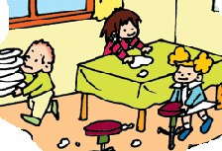
- The room is ______.
They’re ________ the room.

- --- ____ they like ________?
--- No, they don’t.
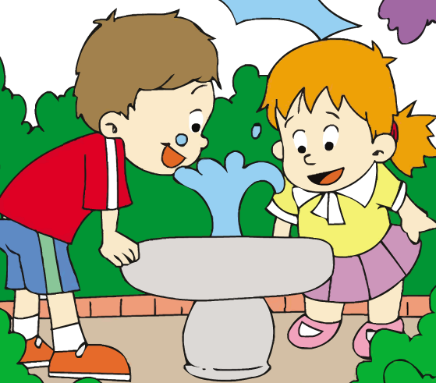
5. It’s fun to drink ______ ______.
（这种方式）
- Read and write. 按要求完成句子。（10%）
1. was different from/ in China/ the food/ Chinese food

2. the Great Wall/ all of/ we/ walk/ can

3. start and finish/ American schools/ what time/ do

4. Does the owl sleep in the day? (请给出肯定回答)
______, it _______.
5. The tiger has four legs. (就划线部分提问)
______ ______ legs does it have?
- Reading. 阅读理解。(共15%)
. Read and judge. 读短文，用“√”“×”判断。（5%）
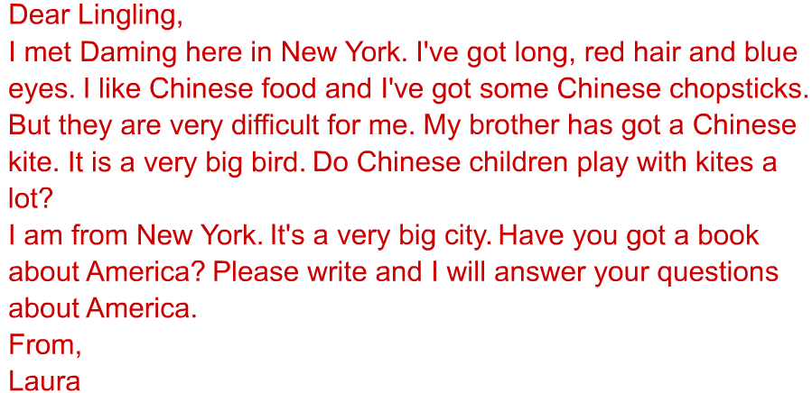

（ ）1.This letter isn’t from Lingling.
（ ）2. Daming met Laura in New York.
（ ）3. Lingling’s brother has got a kite.
（ ）4. Laura can’t use chopsticks very well.
（ ）5. Laura has got black eyes and long, red hair.
.Read and choose. 读短文，选择正确答案。（10%）
Why do people go to school? The aim（目的） of going to school is to study. But it is not easy to meet that aim. You may waste（浪费） either the time or the money. The following are the best ways of studying.
The best time for reading is morning, because in the morning the air is fresh and the mind（头脑） is clear and you can get a better understanding.
When you are studying you must have patience（耐心）. If you don’t know a test well, you must read it again and again till you know it very well.
You must always ask “why”. If you can’t understand what you are studying, write it down and ask your teachers or parents, brothers or friends.
There are many ways of studying. Keep them in your heart and follow them, and you’ll do well in your studies.

（ ）1. People go to school to ______.
A. waste time B. get the aim C. study D. read
（ ）2. This passage tells us ______ ways of studying.
A. one B. two C. three D. four
（ ）3. ______, you may waste either time or money.
A. If you don’t read B. If you don’t go to school
C. If you don’t study hard D. If you don’t ask questions
（ ）4. If you don’t have patience when you study, ______.
A. you may waste time
B. you can get a better understanding
C .you may do well in your study
D. you can’t understand a text
（ ）5. You must always ask “why”, ______.
A. when you say something, begin with “why”
B. if you don’t know something
C. you should ask questions about everything
D. you can only ask “why” when you ask questions

- Composition.写作（请你介绍一下你最喜欢的一种动物，30-40个单词，5%）

___________________________________________________

___________________________________________________

___________________________________________________

___________________________________________________

___________________________________________________

___________________________________________________

市南区2009-2010学年度第一学期
英语学科六年级期末综合练习（十一）听力材料
Tapescript:
I. Listen and choose.
1. I like reading books, and I also like listening to music. B
2. Our school always starts at 8 o’clock . A
3. Don’t make so much noise. C
4. It says snakes are deaf. C
5. Daming visited the UN building yesterday . He was very excited. D
6. We have a big , special dinner on Thanksgiving. D
7. Do you suck your thumb? A
8. The clock is 80 metres high . C
9. Elephants are the largest animals on land. A
10. New Year’s Day is on the first of January. A
II. Listen and tick.
1. ---What’s the time?
---It’s half past seven.
2. It likes jumping . It can run fast. What animal is it？
3. A child sleeps for 8 hours a night .
4. Sam likes noodles best.
5. There are some flowers and chicks on children’s hat at Easter.
III. Listen and choose.
1. How often do you reading books?
2. Do pandas love bamboo?
3. Where does his brother live?
4. Have you got any stamps from China?
5. What are you doing?
IV. Listen and judge.
Module 9 Unit 1
V. Listen and complete.
Yesterday was a holiday. We came to a park. We went there often. We had a picnic. Boys were thirsty. They drank water. It tasted good.

