市南区2009——2010学年度第一学期六年级英语综合练习(二)（时间：40分钟）

Listening Part 听力部分
Ⅰ. Listen and choose. 选出听到的单词或词组，并将其前面的字母标号填在题前的括号里。（10%）
( )1. A. clean | B. course | C. come | D.coat
( )2. A. park | B. restaurant | C. theatre | D. museum
( )3. A. sending | B. painting | C. reading | D. running
( )4. A. Friday | B. Tuesday | C. Sunday | D. Monday
( )5. A. stamp | B. shirt | C. photo | D. story
( )6. A. 25th of December |  | B. 24th of December
C. 25th of November |  | D. 26th of October
( )7. A. suck your thumb |  | B. ride a bike
C. fly kites D. play the flute
( )8. A. row a boat B. jump high
C. climb the mountain D. play the violin
( )9. A. Turn left! B. Turn right!
C. Turn around! D. Turn on!
( )10. A. in the day B. in the morning
C. at night D. at the weekend
Ⅱ. Listen and tick. 根据录音内容，在相应图片下面的括号里划“√”表示。（10%）

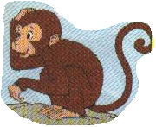
1. 2.
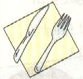
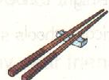

（ ） （ ） （ ） （ ）
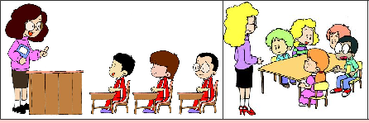

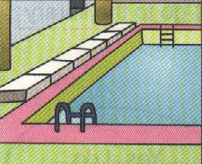


( ) ( )
3.
4.
5.
( ) ( ) ( ) ( )

Ⅲ. Listen and choose. 听问句，选答语。（10%）
( ) 1. A. I often go to Beijing.
B. I’ll go to Beijing .
C. I went to Beijing.
( ) 2. A. They’re from Canada..
B. I come from China.
C. She can speak English.
( ) 3. A. He likes apples .
B. She likes eating .
C. He likes painting.
( ) 4. A. It’s very messy.
B. It’s small.
C. I’ve got some bamboo.
( )5.A.I’m thirsty .
B.I can read.
C.I like playing football.
IV．Listen and judge. 听短文，判断句子是否符合短文意思,符合的用“√”表示， 不符合的用“×”表示。（10%）
（ ）1. The UN building is in America.
（ ）2. The UN wants to make the world peace.
（ ）3. China isn’t in the UN.
（ ）4. There are lots of very tall and big buildings in China .
（ ）5. Daming likes the UN building.
V. Listen and complete. 听录音，补全短文。（10%）
My name’s Mary. ______ are my _______ animals . I’ve got a ______ _______. I often _____ ______ to him. I always ______ my _______ on Saturday. I like reading a lot. I go to the library every week. This summer I’ll go to . And I’ll _____ the UN building. It’ll be amazing.
Writing Part 笔答部分
- Read and choose. 读一读，选出最佳答案，将其前面的字母标号填在题前的括号里。（10%）
( ) 1. I’ve got hair and black eyes .
A. red, long B. black, short C. long, black D. small, red
( ) 2. Chopsticks are very difficult me .
A. of B. in C. to D. about
( ) 3. Brain can’t speak .
A. China B. England C. America D. Chinese
( ) 4.Our school at 8:00,but American schools at 8:30.
A. starts, start B. start , start
C. starts, starts D. start , starts
( ) 5. an owl in the day ? Yes .
A. Do , sleeps B. Does , sleep
C. Does , sleeps D. Do, sleep
( ) 6. My bookshelf is very .I find my books .
A. messy , can B. tidy , can’t
C. clean , can’t D. tidy, can
( ) 7.Daming likes TV . He often TV.
A. watching …watch B. watch , watches
C. watching , watches D. watch, watch
( ) 8. It’s fun to this way !
A. play B. playing C. plays D. played
( ) 9. Christmas is December . It’s the 25th
A. in , at B.on , in B. in , on D on , of
( ) 10. Oh ,sorry .I didn’t bring drinks .
I only brought food .
A. some , any B. any , any
C. some , some D. any , some

- Look and write. 看图补全句子，每空填一个单词。（10%）
  - Pandas love __________.
They eat for __________ _______ a day.(12小时)
2． ________________ is my favourite.
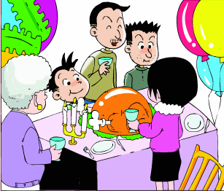
____________ are together.
We have a big, ___________ dinner.
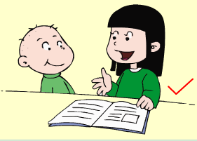
3．I ________ read ___________ to my little brother.
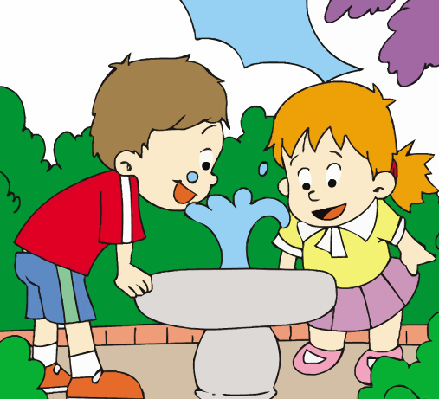
（经常） （故事）
4．__________ ____________ clean water.

- Read and write. 按要求完成句子。（10%）
  - has got / my brother / a Chinese kite （连词成句）
.
  - want to visit / the UN building / do / you （连词成句）

3．in the world / wants to / the UN / make peace （连词成句）

4．I like listening to music. (就划线部分提问)
do you like doing?
5． Have you got buildings like this in China? (给予否定回答)
_______, we __________.
- Reading. 阅读理解。(共15%)
. Read and judge. 读短文，用“√”“×”判断句子是否符合短文意思。（5%）
Lingling: What are you doing?
Amy: I’m tiding my room.
Lingling: Do you often tidy your room?
Amy：Yes, every day. We can play well in a tidy room. We can’t play in a messy room .
Lingling: I know. Do you often tidy your bookshelf?
Amy: No, I don’t. It’s very messy. I can’t find my books.
Lingling:I will help you, Amy. I will tidy your bookshelf.
Amy: Thank you.
Lingling: Now your books are tidy. What do you want to do?
Amy: Let’s read!
Lingling: Good idea. You can choose some books. Then we can read them together.
( )1. Amy tidies her bookshelf every day .
( )2. Lingling will tidy the bookshelf in the school library.
( )3. Amy thinks that they can play well in a tidy room
( )4. Lingling is helping Amy’s mum.
( )5. Amy doesn’t like messy rooms.
.Read and choose. 读短文，选择正确答案。（10%）
Paul could not sleep last night. He woke up early and sat up, and then he lay down again. He felt afraid. “I must be sick,” he thought, “but I must study hard for that test(考试).”
He got up and looked for his history notebook. He finally found it on his chair. He went over(复习) his history notes. But he couldn’t remember any of the facts in his notes. “What shall I do?” he thought and felt terrible.
Just then Paul’s telephone rang, so he put down his notebook and picked up the telephone. “Good morning,” Jack’s voice said. “You must be wrong about that test.”
“What do you mean?” Paul asked weakly （虚弱地）.
“We’re not going to have a test today,” Jack said. “I wrote down the date in my notebook. The test will be next Wednesday. It isn’t today. How do you feel this morning?”
( )1. Paul couldn’t sleep last night. Because he thinks they have _______in the morning.
A. a math test B. a history test C. an English test
( ) 2. Paul found his history notebook _____________
A. on his chair B. on the desk C. on his bed
( )3. Paul went over his history notes, but ___________.
A. He could remember any of the facts in his notes.
B. He couldn’t remember any of the facts in his notes.
C. He did very well .
( )4. What did Jack tell Paul on telephone? _________.
A. The test is really in this morning.
B. The test will be this Wednesday.
C. The test is going to be next Wednesday.
( )5. Paul feels _____ when he knew the test isn’t today.
A. happy B. scared C. afraid
- Composition.写作（5%）
应对今年甲型H1N1流感，我们各校采取了很多的防控措施，请你写一写你们通常的做法或者是给大家提一些建议。要求：内容充实，语句连贯。字数30-40个单词。
___________________________________________________

___________________________________________________

___________________________________________________

六年级英语综合练习(二)听力内容及参考答案
Ⅰ.Listen and choose.
1. Do you often clean your room? D
2. We ate in a restaurant. B
3. I’m sending an email to Mum. A
4. Where did you go last Tuesday? B
5. This is my favourite story. D
6. Christmas is on the 25th of December. A
7. Do you often suck your thumb ? A
8. It’s fun to row a boat. A
9. Turn right! B
10. A fox sleeps at night. C

Ⅱ. Listen and tick.
1. ---What have you got? --- I’ve got a knife and fork.
2. ---Who likes jumping? --- The kangaroo does.
3. In our class, children sit in lines.
4. ---What do you often do at the weekend? ---I often play computer games.
5. ---Tell me more about this place. ---It’s a museum. The clock is fifty metres high.

Ⅲ. Listen and choose.
- Where do you often go?
- Where are these stamps from?
- What does he like doing?
- Is it big or small?
- What’s the matter with you?

Ⅳ. Listen and judge.
Module 9 Unit 1

Ⅴ. Listen and complete.
My name’s Mary. Pandas are my favourite animals. I’ve got a little brother. I often read stories to him. I always tidy my room on Saturday. I like reading a lot. I go to the library every week. This summer I’ll go to America. And I’ll visit the UN building. It’ll be amazing.

试题由下列老师提供：
八大峡小学 魏小川、 北京路小学 苟丽萍、
区实验二小 孙国萍、刘玮、莘县路小学 王媛
由孙国萍统一协调，编排整理。

