市南区2009——2010学年度第一学期六年级英语综合练习(四)（时间：40分钟）

Listening Part 听力部分
Ⅰ.Listen and choose. 请选出你所听到的单词或词组，并将其前面的字母标号填在题前的括号里。（10分）
( )1. A. room | B. sofa | C. bed | D.bookshelf
( )2. A. park | B. restaurant | C. theatre | D. museum
( )3. A. sending | B. painting | C. reading | D. running
( )4. A. Friday | B. Tuesday | C. Sunday | D. Monday
( )5. A. stamp | B. shirt | C. photo | D. story
( )6. A. 25th of December |  | B. 24th of December
C. 25th of November |  | D. 26th of October
( )7. A. make a cake |  | B. love peace
C. make biscuits D. make peace
( )8. A. row a boat B. jump high
C. climb the mountain D. play the violin
( )9. A. in the street B. in a tree
C. in a lake D. in the classroom
( )10. A. in the day B. in the morning
C. at night D. at the weekend
Ⅱ. Listen and choose. 听问句，选答语。（10分）
( ) 1. A. Yes, it is.
B. Yes, there are.
C. No, there is a picture on the wall.
( ) 2. A. I’ve got a picture.
B. Yes, I have.
C. No, she hasn’t.
( ) 3. A. It’s five kilometres.
B. It’s more than two thousand years old .
C. It’s millions of years old.
( ) 4. A. I’m putting my new stamps into my album.
B. He’s sending an e-mail..
C. Yes, he is.
( ) 5. A. Yes , she can.
B. I can write a letter.
C. Of course she is.
Ⅲ. Listen and tick. 请根据听到的内容用“√”勾出相应的
图片。(10分)
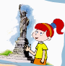
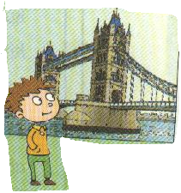

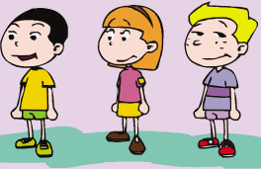
1. 2.

（ ） （ ） （ ） （ ）

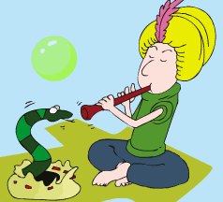
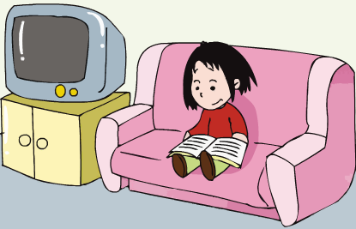
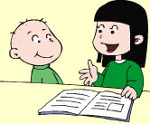
3 4.

( ) ( ) ( ) ( )

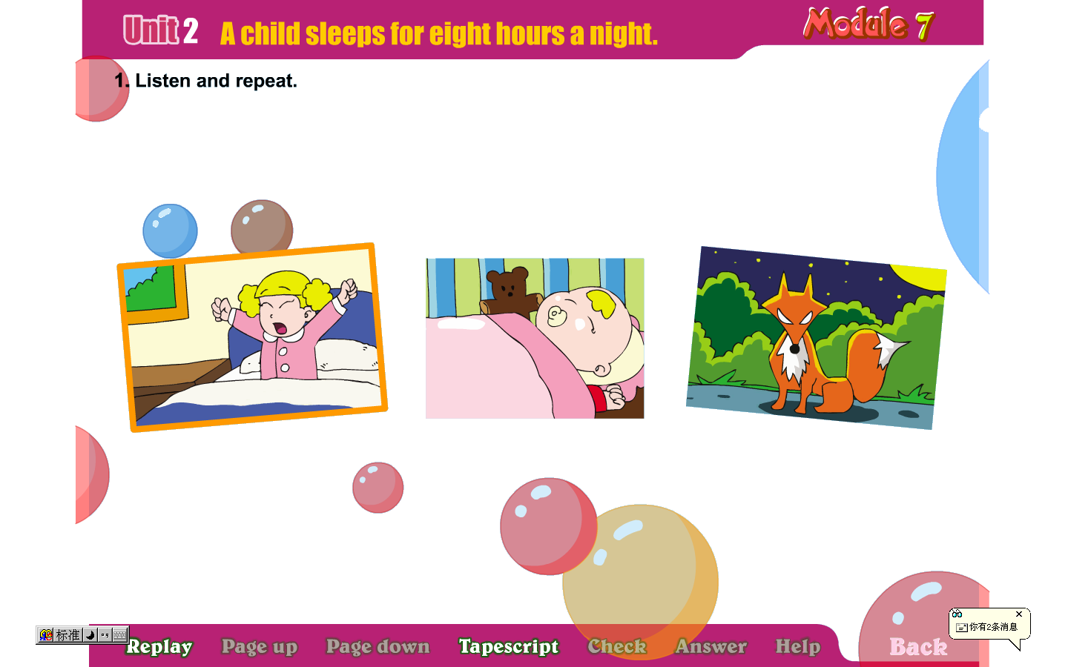

5.

( ) ( )
Ⅳ. Listen and circle T or F. 请根据听到的内容判断对错，并
圈出T或F。（10分）
( ) 1. Simon is visiting in England for the summer.
( ) 2.Daming and Simon are cousins.
( ) 3. Laura wants a Chinese pen pal.
( ) 4. Lingling can’t speak English.
( ) 5. Laura can write a letter in English.
Ⅴ. Listen and fill in the blanks. 听录音，填上所缺单词，补全句子或对话。(10分)
The UN building is a very______building in New York.The UN ______ to ______ ______in the world.Many ______are in the UN.

Writing Part 笔 答 部 分
- Read and choose.(读一读，将正确答案的字母标号写在题前的括号里。) (10%)
( ) 1. ---_____ ______does it sleep?
---It sleeps for sixteen hours a day.
A. How often B. How much
C. When D. How long
( ) 2. Yesterday I ______to a _______. I borrowed two books.
A. go, book store B. went, library
C. went, museum C. go, school
( ) 3.---When is your birthday?
----It’s _____ May.
A. on B. from C. in D. at
( ) 4. He likes _____the piano.
A. plays B. play C. playing D. played
( ) 5. Sam ____got any Chinese stamps .
A. have B. has C. haven’t D. hasn’t
( ) 6. Can you tell me _____ the Summer Palaca?
A. of B. to C. about D. in
( ) 7. ____ he got ____ stamps from China?
- Have , any B. Has, any C. Has, lot D. Have, some
（ ）8.--- How long ______ it sleep?
--- It _____ for 4 hours a day.
A. do, sleep B. does, sleeps
C. does, sleep D. do, sleeping
（ ）9. Do you often ______ your thumb?
A. sucking B. suck C. stopping D. stop
( ) 10. It’s fun to _________ this way.
A. played football B. eat food
C. drank water D. singing songs
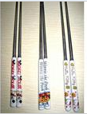
- Read and fill in the blanks.(根据图意，完成句子。每空只填一个单词。) (10%)
- She has got some_______ _______.
She loves China.
- Snakes____ _____. (聋)
They can’t hear the music.
- The UN wants to______ _______in the world.
（制造和平）
China is in the UN.

4. Do you want to ______ the UN building? （参观）
Yes ,_______. （请吧）
5. Only_____ _______water.

- Reorder the words and write.(按照规范的书写要求连词成句。) (10%)

1.drinks, didn’t,any,I,bring

2. are, Chinese, there, people, everywhere

3. like,going,the,zoo,children,to,the

- I swim every week. （就划线部分提问）
_____ _____do you go swimming?

5. Do you want to visit the Great Wall?(否定回答)
_____, we ________.

- Read and judge ‘True’ or ‘False’.(读一读，判断
‘True’ or ‘False’，对的用 “T”表示，反之则用 “F”表示。) (5%)
Dear Laura,
Thank you for your letter. I haven’t got a book about America. But I have got some photos of New York. Daming sent them! Here in China, our school starts at eight o’clock. It finishes at half past four. There are fourty students in our class.We sit in lines in China.Everymorning we do morning exercise.What time do American schools start and finish?
Your friend,
Lingling
- This is an e-mail from Lingling. ( )
- Lingling has got some photos of New York. ( )
- American students sit in lines in class. ( )
- Chinese students do morning exercise every day. ( )
- School starts at eight o’clock and finishes at half past four in America. ( ).

- Read and choose.(读短文，选择正确的答案。) (10%)
Carol is from America. She can speak some Chinese because her mother is Chinese. She’s writing a letter to her cousin in China. It’s about her favourite festival. It’s Christmas. It’s on the 25th of December. People give presents and send cards. There are Christmas trees and lights everywhere. They will have a lot of fun.
( ) 1. What can Carol speak?
  - English.
  - Chinese.
  - Both A &B.
( ) 2. Where does her cousin live?
A. China. B. Canada. C. America.
( ) 3. When is Carol’s favourite festival?
- It’s in autumn.
- It’s on the 25th of December.
C. It’s in January.
( ) 4. Will Carol get a present on that day?
- Yes, he will.
- No, she won’t.
- Of course she will.
( ) 5. What can you see on that day?
- I can see Christmas trees and lights.
- They can see my cousin.
- She can sing a song.

- Composition.(小练笔。) (5%)
请你以 My school 为题目写写你的学校。What subject do you have? When does your school start and finish? What do you often do at school?写30-40词的作文
____________________________________________________________________________________________________________________________________________________________
________________________________________________________________________________________________________
________________________________________________________________________________________________________

六年级英语综合练习题（四）
Ⅰ.Listen and choose.
1. Do you often tidy your bookshelf? D
2. We ate in a restaurant. B
3. I’m sending an email to Mum. A
4. Where did you go last Tuesday? B
5. This is my favourite story. D
6. Christmas is on the 25th of December. A
7. The UN wants to make peace in the world. D
8. It’s fun to row a boat. A
9. It lives in a tree. B
10. A fox sleeps at night. C

Ⅱ. Listen and choose.
1.Is it in our town?
2.What have you got?
3.How old is the Great Wall?
4.What is he doing?
5.What can you do?
Ⅲ. Listen and tick.
1. I have got a pen pal .She’s from America.
2.Be quiet! Don’t make so much noise.
3.Pandas love bamboo.They eat for 12 hours a day.
4. What do you often do? I often read stories to my little brother.
5. A child sleeps for 8 hours a night.
Ⅳ. Listen and circle T or F.
Module5 Unit1
Ⅴ. Listen and fill in the blanks.
The UN building is a very important building in New York.The UN wants to make peace in the world.Many countries are in the UN.

