市南区2009——2010学年度第一学期六年级英语综合练习(六)（时间：40分钟）

Listening Part 听力部分
Ⅰ. Listen and choose. 选出听到的单词或词组，并将其前面的字母标号填在题前的括号里。（10%）
( )1. A. more | B. moon |  | C. million | D. millions
( )2. A. where | B. a lot of |  | C. Stonehenge | D. stone
( )3. A. Canada | B. collect |  | C. stamp album | D. stamps
( )4. A. write | B. here |  | C. what | D. want
( )5. A. hear | B. address |  | C. letter | D. white
( )6. A. China | B. sticks |  | C. different | D. difficult
( )7. A. another |  | B. other | C. thanks | D. fantastic
( )8. A. in the day |  |  | B. a day
C. at night |  |  | D. a night
( )9. A. a mess |  |  | B. a messy room
C. playing well |  |  | D. a tidy room
( )10. A. the fifth |  |  | B. one of the first country
C. one of them |  |  | D. one of the first countries
Ⅱ. Listen and tick. 听句子或小对话，在相应图片下面的括号里划“√”表示。（10%）


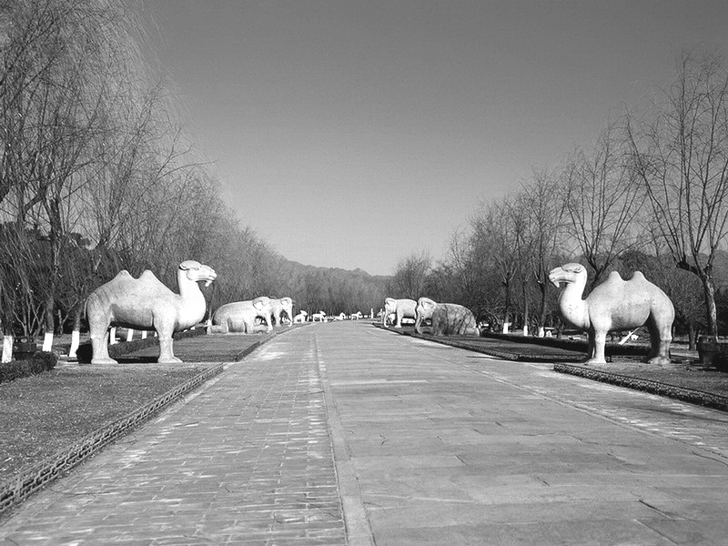
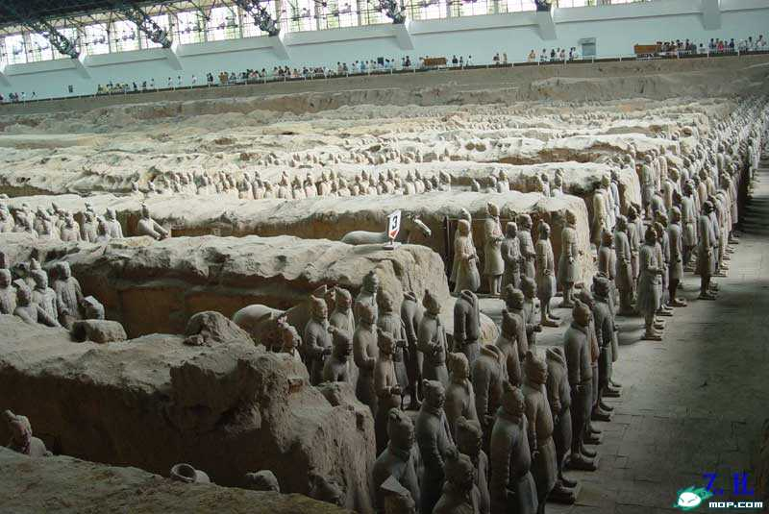
1. 2.

( ) ( ) ( ) ( )




3. 4.

( ) ( ) ( ) ( )

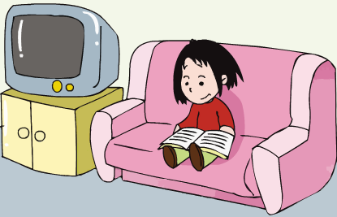

5.

( ) ( )

Ⅲ. Listen and choose. 听问句，选答语。（10%）
( )1. | A. I brought some juice.
 | B. No, we didn’t.
 | C. Yes, I brought some sandwiches.
( )2. | A. I will visit Beijing Zoo.
 | B. I went to the Great Wall.
 | C. I want to go inside the UN building.
( )3. | A. She often tidies her room at the weekend.
 | B. Every Sunday.
 | C. She does it with her mum.
( )4. | A. I sleep for eight hours.
 | B. It sleeps in the day.
 | C. It sleeps for eighteen hours a day.
( )5. | A. I’ve got a knife and fork.
 | B. He’s got a toy car.
 | C. He hasn’t got a kite.

Ⅳ. Listen and judge. 听短文,判断句子是否符合短文意思,符合的用“√”表示， 不符合的用“×”表示。（10%）
（ ）1. Laura met Daming in Beijing.
（ ）2. Laura has got long, red hair.
（ ）3. Laura doesn’t like Chinese food.
（ ）4. Laura has got some Chinese chopsticks.
（ ）5. Laura’s brother’s Chinese kite is a big dragon.
V. Listen and write. 听录音，填单词，补全短文。（10%）
Amy often _ her room. So her room isn’t messy. Sometimes she reads ______ to her _ brother. And she often looks at the CD-ROM. It says pandas love . And snakes are ___. What do you often do?

Writing Part 笔答部分

Ⅵ. Read and choose. 读一读，选出最佳答案，将其前面的字母标号填在题前的括号里。（10%）
( ) 1. What do you need? I need _____ album.
A. a B. an C. some D. /
( ) 2. He summer. He can in the sea.
A. likes… swim B. like… swimming
C. likes… swimming
( ) 3. Look! The snake is coming _______ the bag.
- from B. out of C. out for

( ) 4. does a rabbit sleep? Eleven hours.
A. When B. What C. How long
( ) 5.Changjiang River is one of the longest in the
world.
A. river B. rivers C. a river
( ) 6. Does he want to TV?
- watch B. watches C. watching
( ) 7. Is it big or small?
A. Yes, it is. B. No, it isn’t C. It is big.
( ) 8. Our school at four o’clock.
A. finish B. finishs C. finishes
( ) 9. Have you got a bike?
- Yes, I do. B. No, I have. Yes, I have.
( ) 10. What does he like doing? He likes .
A. paint B. paints C. painting
Ⅶ. Look and write. 看图补全句子，每空填一个单词。（10%）

- ----Have you got a book ________ China?
----No, I ________.
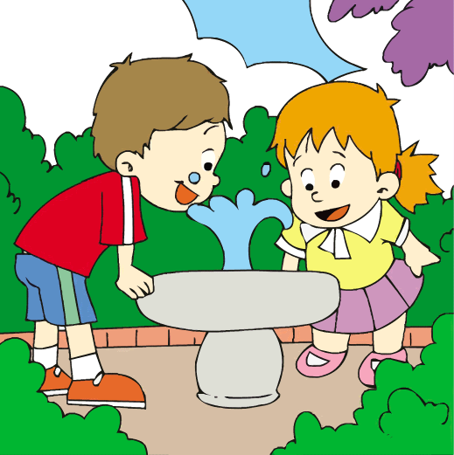
- This water is very _________.

It’s _______ to drink this way.

- The UN _________ to ________ peace in the world.

4. Thanksgiving is my .

We have a big, dinner.


- Pandas eat ________ twelve _________ a day.

Ⅷ. Read and write. 按要求完成句子。（10%）
- often/your/tidy/do/bookshelf/your （连词成句）

2. you/want/do/visit/the UN building/to (连词成句)

- a/sleeps/a/night/child/for/eight/hours (连词成句)

- Does she often tidy her room？ （请给出否定回答）
__________, she ____________.

- A fox sleeps for eight hours. (就划线部分提问)
_________ __________ does a fox sleep?

Ⅸ. Reading. 阅读理解。(共15%)
. Read and judge. 读短文，用“√”“×”判断句子是否符合短文意思。（5%）
Dear Laura，
Thank you for your letter. I haven’t got a book about America. But I have got some photos of New York. Daming sent them! Here in China, our school starts at eight o’clock. It finishes at half past four. What time do American schools start and finish?
Your friend,
Lingling
( ) 1. Laura has got a book about America.
( ) 2. Lingling has got some photos of New York.
( ) 3. Daming sent photos to Lingling.
( ) 4. In China, our school starts at half past eight.
( ) 5. In China, our school finishes at half past four.
.Read and choose. 读短文，选择正确答案。（10%）
Kate is a new student. She is twelve. She is from America. She can speak English very well and she can speak a little Chinese. She is in Nanjing. Her parents are doctors. Kate is studying in a school near her home. She has classes from Monday to Friday. On Saturdays and Sundays, she often plays games with her Chinese friends. She loves China and her Chinese friends.
( ) 1. Kate is ________.
A. a new student B. a Chinese girl C. a doctor D. a driver
( ) 2. Kate can _____________.
A. speak a lot of Chinese B. speak English well
C. speak a little Japanese D. speak little English
( ) 3. Kate often studies___________.
A. from Monday to Friday B. in Beijing
C. on Saturdays and Sundays D. at home
( ) 4. Her parents _____________.
A. are working in a school B. have classes on Mondays
C. often play games with Kate D. are doctors
（ ）5. On Saturdays and Sundays she often __________ with her Chinese friends.
A. has classes B. studies
C. plays basketball D. plays games
Ⅹ. Composition.请以My Weekend为题介绍一下你的爱好，你在周末通常做些什么？上周末你做什么了？下个周末你要做什么？要求语句通顺、语意连贯，字数在30~40词之间。(5%)
________________________________________________________
________________________________________________________
________________________________________________________
________________________________________________________
Tapescript:
I. Listen and choose.
1. The moon is millions of years old.
2. Look! There were lots of stone animals.
3. I’ve got some Canadian stamps in my album.
4. I wrote a poem about Christmas. Do you want to hear it?
5. Here is Laura’s address. You can write to her.
6. Chinese chopsticks are very difficult for me.
7. It thinks the flute is another snake.
8. A baby sleeps for sixteen hours a day.
9. We can’t play well in a messy room.
10. China is one of the first countries in the UN.
II. Listen and tick.
- A: How tall is the clock? B: It’s fifty metres high.
- A: James went to Beijing yesterday. He visited the Ming Tombs.
- A: Have you got any stamps from Canada?
B: No, I haven’t. But I have got some English stamps.
- This animal sleeps in the day and is awake at night. What is it?
- I don’t often watch TV at home. I often read a book at night.

III. Listen and choose.
- Did you bring any drinks for the picnic?
- Where do you want to go?
- How often does Amy tidy her room?
- How long does a snake sleep?
- What present has your brother got?
B C B C B

IV. Listen and judge.
M6 unit1

V. Listen and write.
Amy often tidies her room. So her room isn’t messy. Sometimes she reads stories to her little brother. And she often looks at the CD-ROM. It says pandas love bamboo. And snakes are deaf. What do you often do?

出题人：青岛嘉峪关学校
余慧 张淑琴 王庆华

