市南区2009——2010学年度第一学期六年级英语综合练习(七)（时间：40分钟）

Listening Part 听力部分
Ⅰ. Listen and choose. 选出听到的单词或词组，并将其前面的字母标号填在题前的括号里。（10%）
( )1. A.week | B.weekend | C.end | D. well
( )2. A. and | B. answer | C. album | D. about
( )3. A. said | B. says | C. see | D. say
( )4. A. clean | B. course | C. come | D. came
( )5. A. fun | B. funny | C. forget | D.forgot
( )6. A. speak | B.often | C. because | D. special
( )7. A. bamboo | B. basketball | C. book | D. biscuit
( )8. A. copy | B. city | C. clean | D. coconut
( )9. A. world | B. worry | C. water | D.word
( )10. A. January |  | B. April
C. December |  | D. June
Ⅱ. Listen and tick. 根据录音内容，在相应图片下面的括号里划“√”表示。（10%）





1. 2.

( ) ( ) ( ) ( )
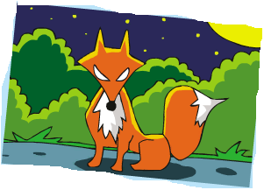

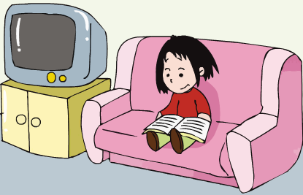
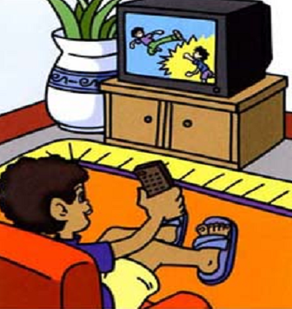
3. 4.

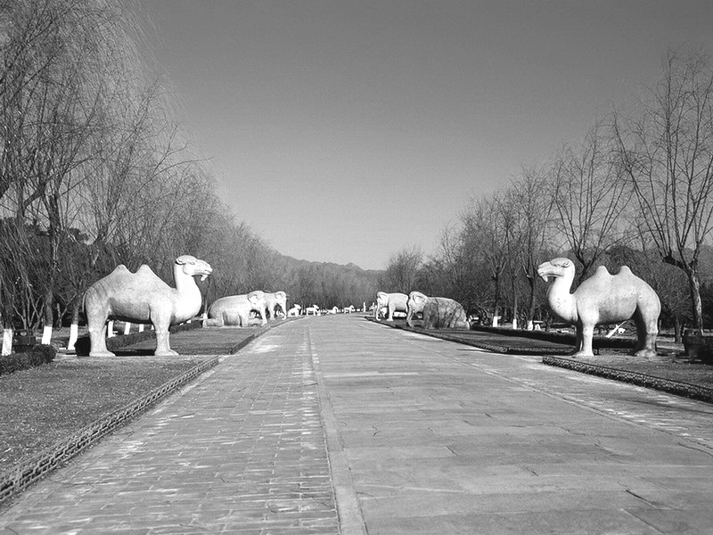
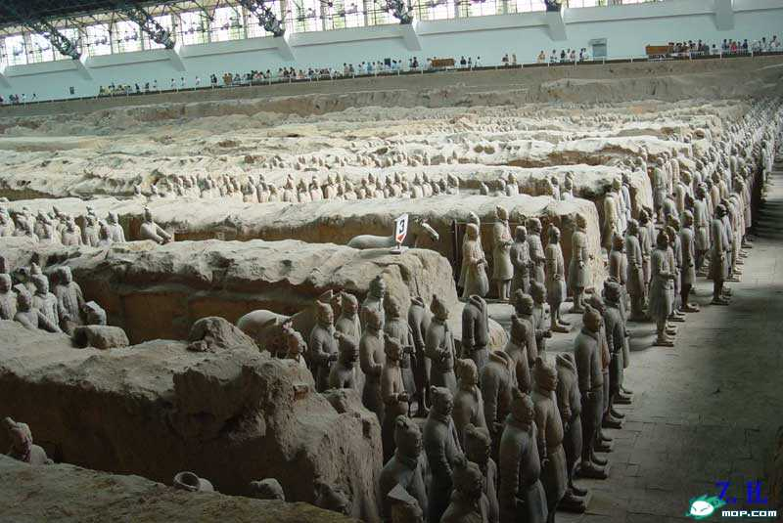
( ) ( ) ( ) ( )
5.

( ) ( )

Ⅲ.Listen and choose. 听问句，选答语。(10%)

( )1. A. This is my school.
B. It’s near to my home.
C. It’s the hospital.

( )2. A. She cleans her room every morning
B. I read books every morning.
C. I do it every morning.

( )3. A. He’s got some new toys.
B. They bought some CDs..
C. She’s got some sandwiches.

( )4. A. They want to visit the Ming Tombs.
B. He wants to visit the museum.
C. They wanted to eat a cake. .

( )5. A. He likes walking.
B. She likes reading newspapers.
C. Yes, she does.
Ⅳ. Listen and draw “√” “×”.听一听，画对号错号。 (10%)
( )1. Lingling hasn’t got a book about America.

( )2. Lingling has got some photos of New York.

( )3. Lingling’s school starts at half past eight.

( )4. It finishes at half past four .

( )5. Laura wrote this letter.
V. Listen and complete. 听录音，补全短文。（10%）

Dear Lingling,
I ________Daming here in New York. I have got long, red hair and blue eyes. I like Chinese food and I’ve got some Chinese_____________. But they are very __________ for me. My brother has got a Chinese kite. Do Chinese___________ play with ________ a lot?
From,
Laura
Writing Part 笔答部分
- Read and choose. 读一读，选出最佳答案，将其前面的字母标号填在题前的括号里。（10%）
( ) 1.This picture is different ________ that one.
A. for B. of c. from D. in
( ）2.The river is ________ kilometres long.
A. hundreds of B. two thousands
C. millions D. two hundreds
( ）3.--- Look! It’s a picture of my family.
---______________
A. It’s fantastic. B.You’re welcome.
C. Pleased to meet you. D. That’s a good idea.
( ) 4 .I’ve got an ______ pen pan .But he lives in ____ now.
A. American, Canada B. America, England C. American, English D. English, America
( ) 5.My birthday is ________ the 8th _______ April.
A. on, in B. on, from C. in, on D. in, of

( ) 6. Elephants sleep ________ three hours a day.
A. of B. for C. in D. from
( ) 7. Simon ______ Chinese stamps. He _______ got some from Daming.
A. like, has B. likes, have C. likes, has D. like, have
( ) 8. I often ________ my room, and my mum often ______ me.
A. tidy, helps B. tidy, help C. tidies,helps D. tidies,help
( ）9. Mr.Green _______ me a letter yesterday. He’s ______ in Shanghai now.
A. send, lives B. send, living C. sent, living D. sent, lives
( ) 10. Does Daming ______ stamps? Yes, he does.
A. collect B. collects C. collecting D. collected

- Look and write. 看图补全句子，每空填一个单词。（10%）
- ---How old is the Great Wall?
--- It’s ______ _______ two thousand years old.
(多于)
你好!
…….
2.. I can _________ to her _______ Chinese.
（用……写）


3. ---Do ________ love ______?
--- No , they don’t. They’re ______.

4. --- The UN ______ to make _______ in the world.

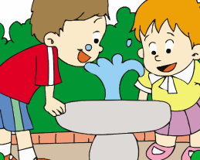

5. It’s ____ ____drink this way.

- Read and write. 按要求完成句子。（10%）
1. Chinese , have got , some , we , chopsticks.(连词成句)

2. can, tell, you, about，I, festivals, Chinese. (连词成句)

3. says, it, deaf, snakes, are. (连词成句)

4. --- Does Amy often tidy her room? (请给出肯定回答)
--- _____, she ______.
5. A baby sleeps for sixteen hours a day.(就划线部分提问)
_______ _______ does a baby sleep?
- Reading. 阅读理解。(共15%)
. Read and judge. 读短文，用“√”“×”判断句子是否符合短文意思。（5%）
Laura is an American girl. She is from New York. It’s a very big city. She has got long, red hair and blue eyes. She likes Chinese food and she has got some Chinese chopsticks. But the chopsticks are very different for her. Her brother has got a Chinese kite. It is a very big bird. She wants a Chinese pen pal. Do you want to be her pen pal？ She can answer your questions about America.
( )1. Laura lives in London.
( )2. Laura hasn’t got any Chinese chopsticks.
( )3. Laura’s brother has got a Chinese kite.
( )4. New York isn’t a very big city.
( )5. Laura can answer some questions about Canada.

.Read and choose. 读短文，选择正确答案。（10%）
Peter is a pupil. He is a good boy. Uncle John lives next to him. Uncle John has no child and he can’t see anything. He works in the factory near Peter’s school. He goes to work at 7:30 in the morning and comes home at 4:30 in the afternoon.
Peter goes to school at 8:00 in the morning and comes home at the same time as Uncle John in the afternoon. On weekdays Peter gets up early to take Uncle John to the factory. After school he takes Uncle John home. On Sundays Peter helps Uncle John clean the house and do some cooking. Uncle John thanks Peter very much. He says, “Peter is a good boy. He is like my son.”
- Peter gets up early to _____.
A. go to school B. run C. help Uncle John D. cook
2. Peter doesn’t take Uncle John to the factory on ______.
A. Weekdays B. Sundays C. Mondays D. Wednesdays
3. Peter helps Uncle John clean the house_____.
A. from Sunday to Saturday B. on Wednesdays
C. on Mondays D. on Sundays
4. School finishes at ____.
A.3:30 B.4:30 C.5:00 D.7:00
5. Which is right（正确的）?______
A. Peter likes Uncle John.
B. Peter is Uncle John’s son.
C. Peter looks like Uncle John’s son
D. Peter looks like Uncle John
- Composition.写作（5%）
请描述一次你的旅行经历，说一说去了哪里，天气怎样，你都干了什么以及你的心情如何等等。要求语句连贯，不少于40个单词。

___________________________________________________

___________________________________________________

___________________________________________________

___________________________________________________

___________________________________________________

市南区2009-2010学年度第一学期英语学科六年级
期末综合练习（七）
Ⅰ. Listen and choose. 选出听到的单词或词组，并将其前面的字母标号填在题前的括号里。（10%）
- What do you do at the weekend?
- I’m putting my new stamps into my album.
- It says snakes are deaf.
- Only drink clean water.
- It’s fun to drink this way.
- Do you often tidy your room?
- It says that pandas love bamboo.
- Beijing is a big city.
- The UN wants to make peace in the world.
- June comes before July.
Ⅱ. Listen and tick. 听音选图，在图下的括号里划‘√’表示。(10%)
- Look! The clock is fifty metres high.
- I’ve got some stamps from Canada. But I haven’t got any English stamps.
- This animal sleeps in the day and is awake at night. What is it?
- I don’t often watch TV at home. I often read a book at night.
5.James went to the Ming Tombs yesterday. He saw lots of stone animals.
Ⅲ.Listen and choose. 听问句，选答语。(10%)
- Where is the museum? B
2.How often do you clean your room? C
3. What has your brother got ? A
4. Where do they want to visit? A
5. What does your grandma like doing? B

Ⅳ. Listen and draw “√” “×”.听一听，画对号错号。 (10%)
Module 6 Unit 2

V. Listen and complete. 听录音，补全短文。（10%）
Dear Lingling,
I met Daming here in New York. I have got long, red hair and blue eyes. I like Chinese food and I’ve got some Chinese chopsticks. But they are very difficult for me. My brother has got a Chinese kite. Do Chinese children play with kites a lot?
From,
Laura
听力部分: 银海学校 纪爱芳、石珊珊、
笔答部分： 新世纪学校 逯扬、李卉

