市南区2009——2010学年度第一学期六年级英语综合练习(九)（时间：40分钟）

Listening Part 听力部分
Ⅰ. Listen and choose. 选出听到的单词或词组，并将其前面的字母标号填在题前的括号里。（10%）
( )1. A. place | B. palace | C. please | D. plus
( )2. A. interesting | B. important | C. idea | D. inside
( )3. A. Australia | B. China | C. America | D. Canada
( )4. A. fox | B. from | C. of | D. fantastic
( )5. A. surprise | B. spring | C. special | D. speak
( )6. A. putting | B. painting | C. drawing | D. doing
( )7. A. millions of |  | B. thousands of
C. hundreds of |  | D. ten thousand
( )8. A. orange juice |  | B. hamburgers
C. sausages |  | D. sandwiches
( )9. A. thirsty B. three |  | C. thirty D. third
( )10. A. clean B. child |  | C. children D. choose


Ⅱ. Listen and tick. 根据录音内容，在相应图片下面的括号里划“√”表示。（10%）
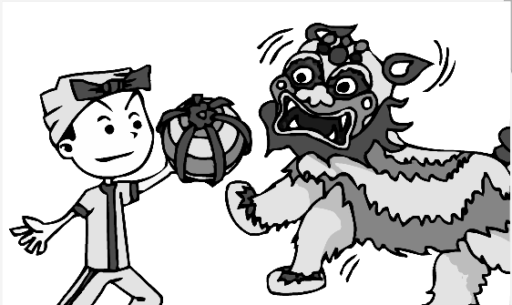


1. 2.



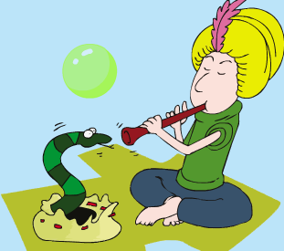
（ ） （ ） （ ） （ ）

3. 4.

（ ） （ ） （ ） （ ）
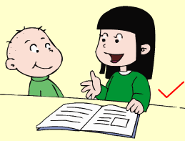
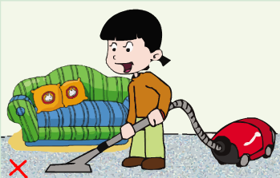
5.

（ ） （ ）
Ⅲ. Listen and choose. 听问句，选答语。（10%）
( ) 1. A. .Sam is playing the flute.
B. I play football every day.
C. They like playing football.
( ) 2. A. It’s big and tall.
B. Yes, that’s a good idea.
C. Thank you.
( ) 3. A. I’ve got a headache.
B. We’ve got a new computer.
C. He’s got a book.
( ) 4. A. I swim every week.
B. I swim very well
C. I like swimming.
( ) 5. A. He often plays basketball
B. No, he doesn’t often watch TV.
C. Yes, he often plays computer games.
IV．Listen and judge. 听短文，判断句子是否符合短文意思,符合的用“√”表示， 不符合的用“×”表示。（10%）
（ ）1. Amy doesn’t often tidy her room.
（ ）2. Amy often tidies her book shelf..
（ ）3. Lingling will help Amy tidy the bookshelf..
（ ）4. Amy and Lingling will read together.
（ ）5. Amy can play well in a messy room.
V. Listen and complete. 听录音，补全短文。（10%）
Hi, friends! My name is Teddy. I live in London. London is a very ________ city. I’ve got a little ________. He _______ skating. We often go to the _______ at the weekend. Sometimes we eat in Chinese_________. We always have fun.
Writing Part 笔答部分
- Read and choose. 读一读，选出最佳答案，将其前面的字母标号填在题前的括号里。（10%）
1. --- This building is _______ of years old.
---__________.
A. many B. million C. hundreds D. thousand
2. Simon really ______ to go to the Great Wall.
A. what B. want C. wants D. won’t
3. Here are some stamps ______ America and Canada ____ you.
A. for, for B . from, from
C. from, for D. for, from
4. She wants a(an) _______ pen pal.
A. America B. American C. England D. Canada
5. Christmas is _____ the 25th of December.
A. on. B. in C. at D. of.
6. I will ask you some questions ______ America.
A. of B. about C. in D. on
7. ---________ does a lion sleep a day?
--- It ______ 12 hours a day.
A. How often, sleeps B. How long, sleeps
C. How long, sleep D. How many, sleep
8. --- ________ Amy like __________TV?
--- No, she doesn’t.
A. Do, watching B. Does, watch
C. Does, watching D. Can, watches
9. Don’t ______ your thumb.
A. sucking B. suck C. stopping D. stop
10. Oh no, I didn’t bring my English book! I ________.
A. forgot B. forget C. remember D. get

- Look and write. 看图补全句子，每空填一个单词。（10%）
- --- I’ve got _________ Chinese _________?

- Pandas love _______. They eat for twelve
________ a day.

- I often _______ ________ to my little brother.

- The UN _______ to make _______
in the world.
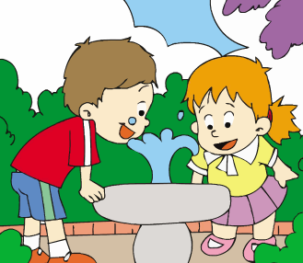
- This water is _______. It’s ______
to drink this way.

- Read and write. 按要求完成句子。（10%）
1. drink/ clean/ only/ water (连词成句)

2. you/ do/ tidy/ often/ room/ your (连词成句)

3. snakes/ says/ it/ deaf/ are(连词成句)

4. Do snakes love music? (请给出否定回答)
______, they _______.
5. It sleeps in the day? (就划线部分提问)
_______ does it sleep?
- Reading. 阅读理解。(共15%)
. Read and judge. 读短文，用“√”“×”判断句子是否符合短文意思。（5%）
Dear Lingling,
I met Daming here in New York. I’ve got long, red hair and blue eyes. I like Chinese food and I’ve got some Chinese chopsticks. But they are very difficult for me. My brother has got a Chinese kite. It is a very big bird. Do Chinese children play with kites a lot?
I am from New York. It’s a very big city. Have you got a book about America? Please write and I will answer your questions about America.
From ,
Laura
（ ）1. Laura met Daming in New york.
（ ）2. Lingling has got some Chinese kites.
（ ）3. Laura’s brother has got a big bird.
（ ）4. New York is a big city.
（ ）5. Laura will answer some questions about China .
.Read and choose. 读短文，选择正确答案。（10%）
Hello, I’m Judy. I’m from Hong Kong .I’ve got long black hair and black eyes. I can speak Chinese and English .I can write in English, too. I love films and I like playing computer games. I like reading books. I often go to the library on Sunday. I don’t often play football. My favourite festival is Spring Festival. We get together and eat dumplings and fish. We have firecrackers. It is really fun. I want a pen pal from America .and we can write in English and Chinese . I can tell you about China.
( )1. Judy is from .
A. China B. America C. England D. Canada
( )2. Judy can speak _________.
A. Chinese B. English C. Japanese D. both A and B
( )3. Judy likes __________.
A. playing football B. playing the flute
C. playing computer games D. watching TV
( )4. In Spring Festival, Judy eat _________.
A. hamburgers B. ice cream C. dumplings D. noodles
( )5. What can’t Judy do?
A. She can’t read books.
B. She can’t write in English .
C. She can’t tell you about China.
D. She can’t play football well.
- Composition.写作（5%）
上面是Judy 介绍自己的情况，你能否和她那样将你的情况如：你的外貌、你的爱好、学校的情况、你的周末、你了解的中国文化等写一下。不少于40-50 个单词。

___________________________________________________

___________________________________________________

___________________________________________________

___________________________________________________

___________________________________________________
__________________________________________________
___________________________________________________

听力内容
I
- Hainan is my favourite place in China.(A)
- It’s a very important building in London.(B)
3. I have a pen pal from America. (C)
4. Simon has got a fantastic CD-ROM. (D)
5. Yesterday I had a big surprise. (A)
6.He likes painting.(B)
7.This bridge is hundreds of years old.(C)
8. Here are your sandwiches. (D)
9.I’m thirsty I want some drinks. (A)
10. A child sleeps for 8 hours a night.(B)
II.
- I like Chinese dancing. It’s beautiful. (1st picture)
- Is China in the UN? Yes, China is one of the first countries in the UN. (2nd picture)
- The snake thinks the flute is another snake. It’s copying it. ( 2nd picture)
- Where are you from, Peter? I’m from Canada. (1st picture).
- Do you often read stories to your little brother? Yes, every day. ( 1st picture)
III.
1. What do Sam and Daming like doing? (C)
2. Do you want to go inside the museum?(B)
3. What have you got in your room? (B)
4. How often do you swim?(A)
5. What does your father often do at the weekend?(A)
IV. Module 8 Unit 1
V.
Hi, friends! My name is Teddy. I live in London. London is a very big city. I’ve got a little brother. He likes skating. We often go to the park at the weekend. Sometimes we eat in Chinese restaurants. We always have fun.

青岛莱芜一路小学 于秀霞 赵玲 张艳霞

