市南区2009——2010学年度第一学期六年级英语综合练习(十二)（时间：40分钟）

Listening Part 听力部分
Ⅰ. Listen and choose. 选出听到的单词或词组，并将其前面的字母标号填在题前的括号里。（10%）
( )1. A. was | B. will | C. were | D. are
( )2. A. 62 | B. 48 | C. 64 | D. 56
( )3. A. November | B. Auguster | C. December | D. June
( )4. A. said | B. scary | C. interested | D. sad
( )5. A. line | B. left | C. around | D. right
( )6. A. bamboo | B. book | C. banana | D. build
( )7. A. thank | B. thing | C. thirsty | D. three
( )8. A. way | B. week | C. where | D. world
( )9. A. address | B. around | C. answer | D. awake
( )10. A. Australia |  | B. China
C. America |  | D. Canada

Ⅱ. Listen and tick. 根据录音内容，在相应图片下面的括号里划“√”表示。（10%）
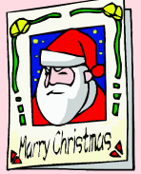
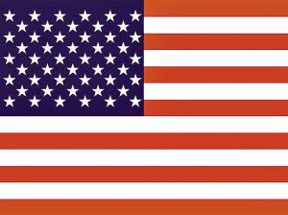

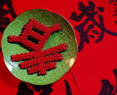
1. 2.

（ ） （ ） （ ） （ ）
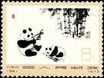
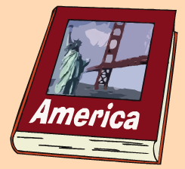
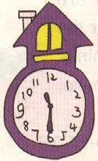
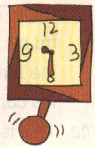
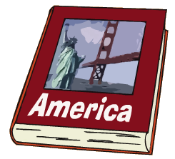
3. 4.

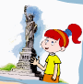
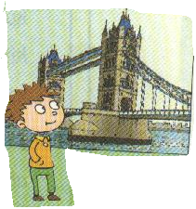
（ ） （ ） （ ） （ ）
5.

（ ） （ ）

Ⅲ. Listen and choose. 听问句，选答语。（10%）
( ) 1. A. They’re from America.
B. They are Five-Finger Mountains..
C. They are good.
( ) 2. A. He ate Chinese food.
B. He go to New York.
C. He saw Chinese dancing.
( ) 3. A. Yes,I do.
B. No, I didn’t.
C. Yes, I will.
( ) 4. A. I want an English pen pal.
B. No, I want a Chinese pen pal.
C. Yes, he does.
( ) 5. A. I often to to Beijing.
B. I’ll go to Beijing.
C. I went to Beijing.
IV．Listen and judge. 听短文，判断句子是否符合短文意思,符合的用“√”表示， 不符合的用“×”表示。（10%）
（ ）1. This is a letter from New York.
（ ）2. Lingling has got long,red hair.
（ ）3. Laura likes Chinese food.
（ ）4. Daming has got a Chinese kite.
（ ）5. Laura is from New York.
V. Listen and complete. 听录音，补全短文。（10%）
The UN ______ is very important in New York. The UN ______ to make ______ in the ______.Many countries are in the UN.China is one of the ______ countries in the UN.

Writing Part 笔答部分
- Read and choose. 读一读，选出最佳答案，将其前面的字母标号填在题前的括号里。（10%）
1.Do you like ______?
A. sings B.sing C.singing D.sang
2.The kangaroo _____ jumping.
A. liked B. liking C. likes D. like
3. Let’s ______ a song
A. sing B. sings C.sang D.singing
4.---______ Xiaoqiang like watching TV?
---Yes,he does.
A. do B. does C.did D.is
5. It’s fun to ______ this way
A. drank B. drink C. drinking D. drinks
6. ---Here are your sandwiches.
---_____________________
A. You are welcome B.Oh,no.
C. Thank you. D. Maybe
7. A child sleeps _____ eight hours _____ night.
A. of, / B. for, a C. at. a D. from, /
8. Stand _____ lines.
A. at B.on C. in D. of
9. Have you got ______ stamps?
A. any B. lot B. a D an
10.Sam _____ got a new book.
A. has B. was C. have D. having
- Look and write. 看图补全句子，每空填一个单词。（10%）
- A _____ sleeps for eight ______ a night.
- They are very _____for him.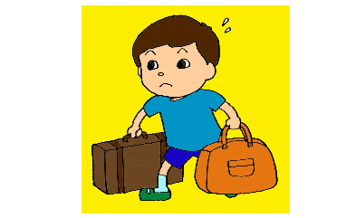
- It ______ at _____ ______ six.
（六点半）
- Have you got _______ American book?

5.My brother ____ got some _______ ______.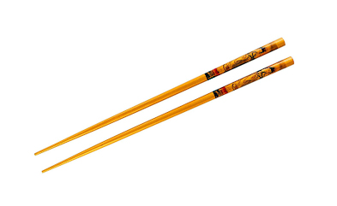

- Read and write. 按要求完成句子。（10%）
1. dancing / the / we / in / Chinese / street / saw (连词成句)

2. got / I’ve / chopsticks / some (连词成句)

3. child / for / a / sleeps / eight / night / a / hours (连词成句)

4. Does he often tidy his room? (请给出肯定回答)
______, he _______.
5. It lives in a tree. (就划线部分提问)
_______ _______ it live?
- Reading. 阅读理解。(共15%)
. Read and judge. 读短文，用“√”“×”判断句子是否符合短文意思。（5%）
Dear Laura,
Thank you for your letter. I haven’t got a book about America. But I have got some photos of New York. Daming sent them! Here in China, our school starts at eight o’clock. It finishes at half past four. What time do American schools start and finish?
Your friend,
Lingling
（ ）1. This letter is from Daming.
（ ）2. Lingling has got some books about America.
（ ）3. School finishes at four o’clock in China.
（ ）4. Here in China, school starts at half past four.
（ ）5. Daming sent photos of China to Lingling.
.Read and choose. 读短文，选择正确答案。（10%）

American Students’ Education(教育)
American school begins in September after a long summer holiday.There’re two terms（学期） in a school year.The first term is from Septemper to January, and the second term is from February to June.Most American children begin to go to school when they’re five years old. Most students are seventeen or eighteen years old when they finish high school.
High school students take only five or six subjects each term.They usually go to the same class every day,and they have homework for every class.After class,they do a lot of interesting things.
After high school（高中） ,many students go to college(大学).They usually have to pay(付款)a lot of money（钱）. So, many college students work after class to get money for their studies.

( ) 1.In America, summer holidays begin in ________.
A. July B.September C.May D.February
( )2.Most American children go to school at the age（年龄） of ________.
A.five B.seven C.eighteen D.seventeen
( )3.High school students______after class.
A.do housework B.go to work
C.play baseball D.do interesting things
( )4.In order to (为了)___,many American college students work after class.
A.help their parents B.get money for their studies
C.help others D.learn some useful things
( )5.After high school , many students go to ______.
A.cities B.work C.college D.towns
- Composition.写作（5%）
Write a letter to Betty. 假如你是Honghong, 请给Betty写一封回信，向她介绍一下你自己（居住城市、家庭、语言、爱好、学校情况等）。要求：内容充实，语句连贯。30-40个单词。
___________________________________________________

___________________________________________________

___________________________________________________

___________________________________________________

___________________________________________________

___________________________________________________

___________________________________________________

听力材料：
Ⅰ. Listen and choose.
- There were many books on the bookshelf.
- The tall building is 64 metres high.
- Chrismas is in December.
- Daming’s mom is very sad.
- Stand in line.
- pandas love bamboo.
- Xiaoqiang feels very thirsty.
- It’s fun to play this way.
- Please tell me your address.
- The stamp is from America.
Ⅱ. Listen and tick.
- What’s your favourite festival?
My favourite festival is Chrismas.
- Where are you from?
I’m from Canada.
- Have you got some Chinese stamps?
No,I haven’t. I have got some books about America.
- What’s the time? It’s half past 11.
- Where are you going this summer?
I’m going to England.
Ⅲ. Listen and choose.
- Where are the stamps from?
- What did Sam see yesterday?
- Will you have a picnic?
- Do you want an English pen pal?
- Where do you often go?
IV．Listen and judge.
Module 6 unit 1
V. Listen and complete.
The UN building is very important in New York. The UN wants to make peace in the world. Many countries are in the UN.China is one of the first countries in the UN.
试卷提供：太平路丁旭军

