市南区2009——2010学年度第一学期六年级英语综合练习(十三)（时间：40分钟）

Listening Part 听力部分
Ⅰ. Listen and choose. 选出听到的单词或词组，并将其前面的字母标号填在题前的括号里。（10%）
( )1. | A. Three metres.
 | B. Three hours.
 | C. Yes, it does.
( )2. | A. I’m going to school.
 | B. I went to the library.
 | C. I often play computer games.
( )3. | A. Yes, I am.
 | B. No, I can’t.
 | C. Yes, we haven’t.
( )4. | A. I’m going to have a party.
 | B. I play football with my friends.
 | C. I wrote emails.
( )5. | A. No, she likes drawing.
 | B. No, she isn’t.
 | C. No, she’s swimming.
( )1. A. only | B. tall | C. all | D. long
( )2. A. park | B. restaurant | C. museum | D. theatre
( )3. A. place | B. weekend | C. world | D. surprise
( )4. A. England | B. America | C. Canada | D. China
( )5. A. streets | B. sleep | C. shops | D. shoes
( )6. A. photo | B. pal | C. poem | D. place
( )7. A. the 25th of December |  | B. the 24th of December
C. the 25th of November |  | D. the 26th of October
( )8. A. coming out |  | B. copying it
C. coming from |  | D. sending emails
( )9. A. playing football |  | B. like painting
C. like jumping |  | D. eating food
( )10. A. Turn left! |  | B. Turn right!
C. Turn around! |  | D. Be quiet!



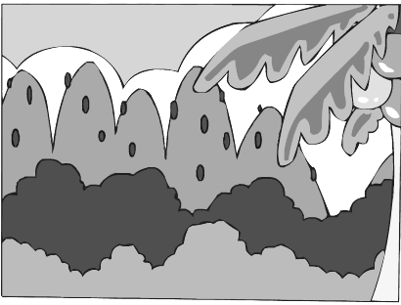
Ⅱ. Listen and tick. 听句子，在相应图片下面的括号里划“√”表示。（10%）
1. 2.

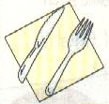
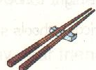
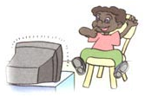
（ ） （ ） （ ） （ ）

3. 4.

（ ） （ ） （ ） （ ）
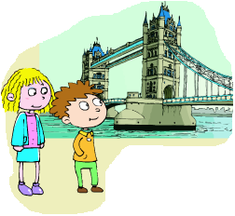

5.

（ ） （ ）
Ⅲ. Listen and write. 听录音，填上所缺单词，补全短文。（10%）
Daming is my friend and I want you to be my ______ pal, too. I live in New York, but I am not_________. I am from London. It’s in _______. So we are all _______! Do you like China? I want to ______ China someday.

Ⅳ. Listen and choose. 听问句，选答语。（10%）
V. Listen and judge. 听短文，判断句子是否符合短文意思，符合的用“√”表示， 不符合的用“×”表示。（10%）
（ ）1. Laura has got long, black hair.
（ ）2. Laura met Daming in America.
（ ）3. Laura doesn’t like Chinese food.
（ ）4. Laura can use Chinese chopsticks very well.
（ ）5. Laura’s brother’s kite is a big bird.
Writing Part 笔答部分
Ⅵ. Reorder the words and write. 按照书写要求完成句子。（10%）
1. I / her / in / write / to / can / English

2. is / Chinatown / there / New York / a / in

3. what / he / is / doing

4. Can she speak English?(否定回答)
_________, she____________.
5. It says snakes are deaf.
_________ does it say?

Ⅶ. Look and write. 看图补全句子，每空填一个单词。（10%）
1. ---What are you doing?
---I’m _______ my stamps _______ my album.

2. ---Welcome to Qingdao!
---Oh, there are lots of very
_______ and _______ buildings here.

3. ---What do you do at home?
---I often _______ _______ to my little brother.
(读故事)
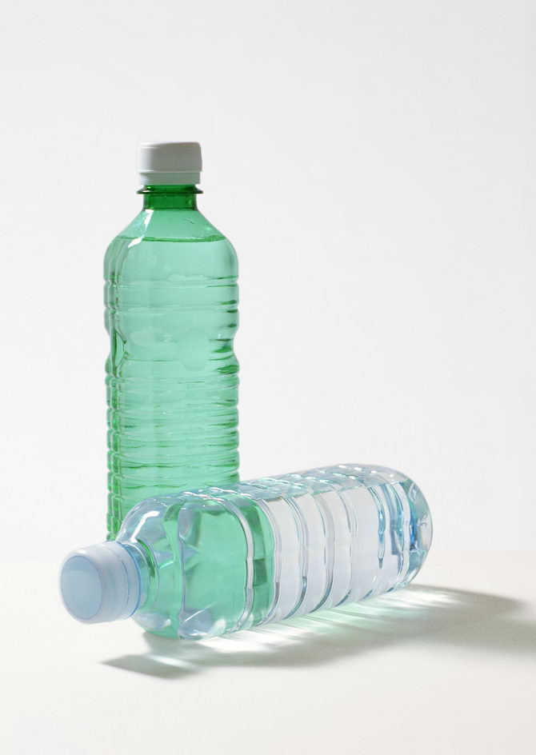
4. ---What have you got for the picnic?
---I’ve got some _______ _______.
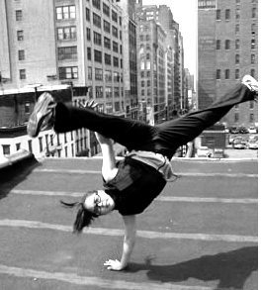
（干净的水）
5. ---Can you dance?
---Yes, I can. Look, it’s fun to dance
_______ _______! （这种方式）

Ⅷ. Read and choose. 读一读，选出最佳答案，将其前面的字母标号填在题前的括号里。（10%）
( ) 1. Snakes don’t like music, they’re ______.
A. blind B. deaf C. good D. fantastic
( ) 2. Pandas eat for _____ hours a day.
A. 2nd B. 12 C. 6th D.12th
( ) 3. My bookshelf isn’t tidy, it’s a little ______.
A. clean B. big C. messy D. tidy
( ) 4. Our school starts nine o’clock.
A. at B. on C. in D. about
( ) 5. I’m . I want to eat a sandwich.
A. thirsty B. tired C. hungry D. ill
( ) 6. Can you tell me about ________ festivals?
A. American B. the USA C. America D. China
( ) 7. Halloween is ______very important festival for children.
A. an B. / C. a D.some
( )8 There are lots of ________ in the zoo.
A. river B. animals C. a stone D. stone animal
( ) 9. I need ______ sleep.
A. a B. to C. 不填 D. of
( ) 10.Can you tell _______ about China?
A. he B. him C. his D. she
Ⅸ. Read and judge. 读短文，判断句子是否符合短文意思，符合的在括号里划“√”表示，不符合的划“×”表示。（5%）
Simon: Tell me about the Great Wall. I want to go there.
Daming: You can! When you visit me in China, we’ll go. It’s near to my home.
Simon: Can we walk all of the Great Wall, Daming?
Daming: No, we can’t walk all of it. It’s too long!
Simon: Why? How long is it?
Daming: It’s ten thousand li long.
Simon: Li?
Daming: Five thousand kilometres!
Simon: Wow! How old is it?
Daming: Very old! It is more than two thousand years old!
Simon: The moon is only two thousand years old.
Daming: Not the moon, Simon. The Great Wall! The moon is millions of years old!
( )1. Simon wants to go to the Great Wall.
( )2. Simon can walk all of the Great Wall.
( )3. The Great Wall is not very far from Daming’s home.
( )4. The Great Wall is 500 kilometres long.
( )5. The moon is thousands of years old.
Ⅹ. Read and choose. 读短文，选择正确答案，将其前面的字母标号填在题前的括号里。（10%）
Alice lives in America. She’s got short hair and blue eyes. She is tall.
Alice and her sister Ann are twins（双胞胎）. They look the same（同样的）, but they are very different. Alice likes reading books, she can speak some Chinese! Ann likes singing and collecting stamps. At the weekend, they always watch TV together.
Alice’s parents work in a school. They’re teachers. They go to work by bus every day.
Today is Thanksgiving. Alice’s family have a big, special dinner. They say thank you for all the good things. They say they will go to China after Christmas! Alice is very happy.
( )1. Alice’s home is in ______.
A. China B. America C. Australia D. Canada
( )2. Alice ________.
A. is a tall girl B. is short
C. has got black eyes D. has got long hair
( )3. Alice and Ann’s hobbies（爱好）are _______.
A. not good B. listening to music
C. the same D. different
( )4. Alice’s family have a big dinner at ______.
A. Thanksgiving B. Christmas
C. Thanksgiving D. Halloween
( )5. Alice is going to visit China with her ______.
A. friends B. family C. teacher D. uncle
Ⅺ. Composition. 请介绍你的一位好朋友，可以介绍他（她）的外貌、爱好、本领以及你们在学校里都做哪些事情。要求语句通顺，内容不少于5句话。（5%）
My Friend
________________________________________________________
________________________________________________________
________________________________________________________
________________________________________________________
________________________________________________________

一，1. How tall is this bulding?
2. There is a museum next to the zoo.
3. The UN makes the peace in the world.
4. Simon is an American,but he is in Canada now.
5. The pandas sleep for 10 hours at night.
6. There is my favourite place in this pccture.
7. The Christmas is on the 25th of December.
8. The snake is copying it.
9. She likes painting,but her sister likes eating food.
10. Be quiet! Class begins.

二，1，How long is this bridge? It’s 1,000 metres long.
2,There is a Chinatown in New York
3,They use chopsticks in China.
4,I don’t like playing football, I like cleaning the room.
5,We went to London last summer holiday.

三 Daming is my friend and I want you to be my _pen pal , too. I live in New York, but I am not American. I am from London. It’s in England. So we are all friends! Do you like China? I want to visit China someday.

四 1. How many hours do you go there?
2. What do you often do?
3. Haven’t you got big buildings like this in China?
4. What are you going to do?
5. Does she like swimming?
五，M6U1
（本试题由香港路小学冷超，张雯提供）

