2014-2015学年度第一学期四年级英语书写练习题一
班级 姓名 成绩
Ⅰ、Read ,choose and write.(看图选词补全句子)10分
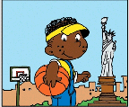
1、John is . (Chinese/American）
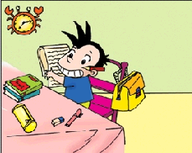
2. He his homework. (did/finished)
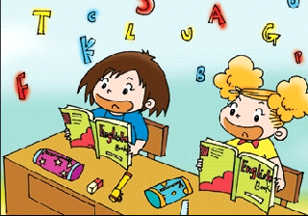
3. She usually English and Maths. (learn/learns)
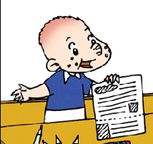
4. Look, I this newspaper. (printed/print)

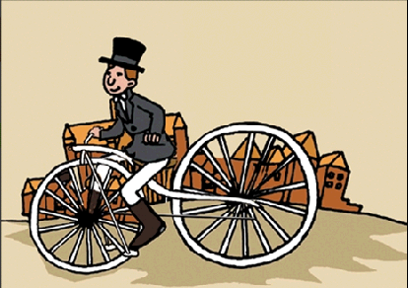
5. Look at the man on the . (bicycle/ship)

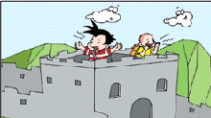
6. We to the top. (climbed/went)

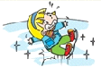
7. First, I over. (fall/fell)
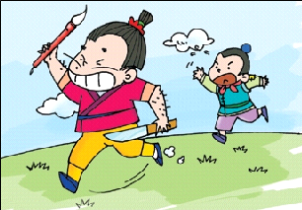
8. He Ma Liang’s magic paintbrush. (take/took)
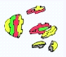
9. Did you your toy? (break/broke)


10. I saw a on the TV. (toy/monster)

Ⅱ、Read, choose and write the sentences.(看图选句并抄写在相应图下)10分

I cleaned my room. I washed my trousers. Mr. Smart cooked noodles
Chinese people invented paper. Chinese people invented printing.

1. 2. 3. 4. 5.
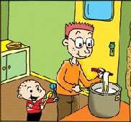
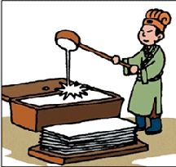
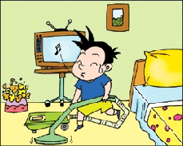
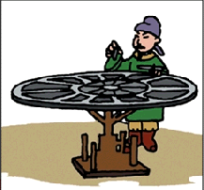
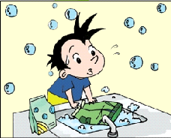

1. 2.

3. 4.

5.

Ⅲ、Read ,choose and write.(看图片用单词的正确形式填空)10分
is play go see have

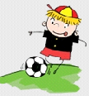
Lijie usually football.


Yesterday his birthday. He didn’t play football.
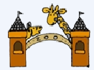
.
He to the zoo with his parents.

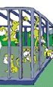
And he lots of animals.

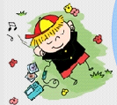
He a good time.

Ⅳ、Copy the sentences.( 按正确形式抄写句子，注意大小写和标点符号) 10分

1. didn’t / I/ no

2. I / yesterday / cleaned my room

3. break your toy / you / did

4. come back / didn’t / he

5. invented / Chinese / paper / people /

