市南区2009——2010学年度第一学期六年级英语综合练习(五)（时间：40分钟）

Listening Part 听力部分
Ⅰ.Listen and choose. 请选出你所听到的单词或词组，并将其前面的字母标号填在题前的括号里。（10分）
( )1. A. room | B. sofa | C. bed | D.bookshelf
( )2. A. park | B. restaurant | C. theatre | D. museum
( )3. A. sending | B. painting | C. reading | D. running
( )4. A. Friday | B. Tuesday | C. Sunday | D. Monday
( )5. A. stamp | B. shirt | C. photo | D. story
( )6. A. 25th of December |  | B. 24th of December
C. 25th of November |  | D. 26th of October
( )7. A. make a cake |  | B. love peace
C. make biscuits D. make peace
( )8. A. row a boat B. jump high
C. climb the mountain D. play the violin
( )9. A. in the street B. in a tree
C. in a lake D. in the classroom
( )10. A. in the day B. in the morning
C. at night D. at the weekend
Ⅱ.Listen and tick. 请根据听到的内容用“√”勾出相应的
图片。(10分)
1. 2.
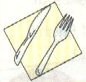
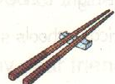
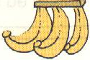


（ ） （ ） （ ） （ ）
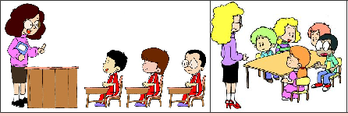

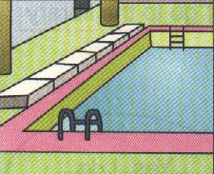


( ) ( )
3.
4.
5.
( ) ( ) ( ) ( )

Ⅲ. Listen and choose. 听问句，选答语。（10分）
- A. We ate Chinese food yesterday.
  - We went to New York.
  - We saw Chinese dancing.

- A. They’re from America.
  - They’re Five-Finger Mountains.
  - They are good.
- A. It’s two metres long.
  - It’s two metres tall.
  - It’s two years old.
- A. He usually does his homework at the weekend.
  - He watched TV last weekend.
  - She usually rides her bike at the weekend.
- A. I want an English pen pal.
  - No, I want a Chinese pen pal.
  - Yes, he does.
Ⅳ. Listen and judge. 请根据听到的内容判断对错，用“√”或“Ⅹ”表示。（10分）
( )1. Simon likes collecting stamps.
( )2. Simon has got some stamps from China.
( )3. Daming often sends Simon letters.
( )4. Daming doesn’t collect stamps.
( )5. Simon gives Daming some American stamps.
Ⅴ. Listen and complete. 请根据听到的内容补全下面的表
格。（10分）
Hi, I’m Fran. I’m from _______. I like reading books. I don’t like playing football. I ________ riding my bike. And I like ___________ television. I don’t like _________. And I don’t like ________ my room. How about you?

Writing Part 笔答部分
Ⅵ. Read and choose. 读一读，选出最佳答案，将其前面的字母标号写在题前的括号里。( 10分)
( ) 1. Let’s _______ games now.
A. playing B. play C. to play D. played
( ) 2. A child for eight hours a night.
A. sleeps B. sleeping C. sleep D. sleeping
( ) 3. --Did you ____ TV yesterday?
--No, I didn’t. I _____ my bike yesterday.
A. watched; ride B. watched; rode
C. watch; rode D. watch; ride
( ) 4. Our school starts nine o’clock___ the morning.
A. in; at B. on ; in C. at; in D. in; at
( ) 5. Shanshan is my friend. _____bag is red. ____ is blue. A. Her, My B. Hers, My C. She, Mine D. Her, Mine
( ) 6. The Great Wall is long.
A. five thousand kilometres B. two thousand li
C. five thousands kilometer D. ten thousands li
( )7. This book is different _____ that one.
A. of B. from C. for D. in
( ) 8. My birthday is _____the 20th _____ October.
A. in;of B. in; in C. on; at; D. on; of
( ) 9. make so much noise!
A. Don’t B. Aren’t C. Haven’t D. Do
( ) 10. Thanksgiving is ___ important festival _____ America.
A. a, in B. / , in C. an, / D. an, in
Ⅶ. Look and write. 看图补全句子，每空添一个单词。

（10分）
1. ________ eat for twelve _______ a day.

2. She often _______ _______ to her
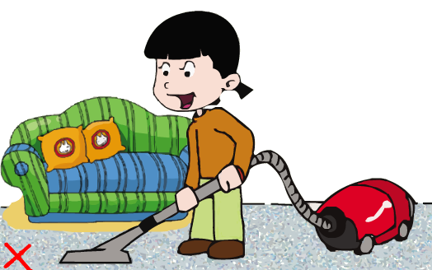
little brother.
3. She doesn’t like _________

her ______.
4. We saw ________ _______in the street.

5. –Have you got any ______ from ________?
-- Yes, I have.
Ⅷ. Read and write. 按要求完成句子。 (10分)
1. clean, only, water, drink

2. at, what, you, the, do, weekend, do

3. years, it’s, more, thousand, than, two, old

4. Do pandas love bamboo? (请给出肯定回答)
________, they _________.
5. I’m looking at my new CD-ROM.（就划线部分提问）
_________ are you doing?
Ⅸ. Reading. 阅读理解( 15分)
. Read and judge. 读短文，用“√”“×”判断句子是否符合短文意思。（5%）
Dear Lingling,
I met Daming here in New York. I’ve got long , red hair and blue eyes. I like Chinese food and I’ve got some Chinese chopsticks. But they are very difficult for me. My brother has got a Chinese kite. It is a very big bird. Do Chinese children play with kites a lot?
I am from New York. It’s a very big city. Have you got a book about America? Please write and I will answer your questions about America.
From,
Laura
( ) 1. This is a letter from New York.
( ) 2. Lingling has got long,red hair.
( ) 3. Laura likes Chinese food.
( ) 4. Daming has got a Chinese kite.
( ) 5. Laura is from New York.
.Read and choose. 读短文，选择正确答案。（10%）
It is Saturday. The Greens are at home. Mrs. Green is in the kitchen. She’s making apple pies. The pies are very delicious. Do you want to have a taste? Mr. Green isn’t in the living room. He is outside. He is washing his car. The car is new and very beautiful. So he looks after it very well. Jim is in the garden. He is playing football with some other boys. Where is his sister, Sue? She’s in her bedroom with her friend, Ann. They are watching the Animal World.
( ) 1. There are ______ people in Mr. Green’s family.
A. six B. four C. two D. three
( ) 2. Mrs. Green is ______.
A. tasting the apple pies B. watching TV
C. cooking D. eating a cake
( ) 3. Mr. Green looks after _____ very well.
A. Mrs. Green B. his daughter
C. his family D. his car
( ) 4. Who is playing outside? ________
A. Mrs. Green and Sue B. Some boys
C. Sue and Ann D. Some girls
( ) 5. Sue and Ann are ________.
A. watching TV in the living room.
B. playing football in the open air.
C. watching TV in Sue’s room.
D. playing in Ann’s room.
Ⅹ. Composition.写作（5%） 写一写你和你的家人在周末都经常做些什么，喜欢做些什么，开心吗？（ 30----40词）。

六上英语综合练习五听力内容
Ⅰ.Listen and choose.
1. We can play well in a tidy room. A
2. Xiangqiang wants to visit the museum. D
3. Xianaqiang likes painting. B.
4. We have an English class on Tuesday. B
5. This is my favorite stamp album. A
6. My birthday is on the 25th of November. C
7. All of the people in the world love peace. B
8. I often play the violin at the weekend. D
9. There are lots of fish in a lake . C
10. A snake sleeps in the day. A

Ⅱ. Listen and tick.
1. – Have you got a knife and fork?
-- No, I haven’t. I’ve got chopsticks. P2
2. -– What did you have for breakfast?
-- I had some bread and drink. P2
3. In England children sit around tables. P2
4. – What do you like doing at the weekend?
-- I like swimming. P2
5. --Tell me more about this place.
– It’s a bridge. It’s more than two kilometres long. P1

Ⅲ. Listen and choose.
1. Where did you go last summmer holiday ? B
2. Where are the stamps from? A
3. How old is the museum? C
4. What does she usually do at the weekend? C
5. Do you want an American pen pal? B

Ⅳ. Listen and judge. Module 3 Unit 1
1. √ 2. × 3. × 4. √ 5. √

Ⅴ. Activity Book P36 . 2
Hi, I’m Fran. I’m from England. I like reading books. I don’t like playing football. I love riding my bike. And I like watching television. I don’t like swimming. And I don’t like tidying my room. How about you?

