2015-2016学年度第一学期五年级英语期末练习题（一）
（时间：40分钟）

Listening Part 听力部分
Ⅰ. Listen and tick. 听音选图，在图下的括号里划‘√’表示。(10%)
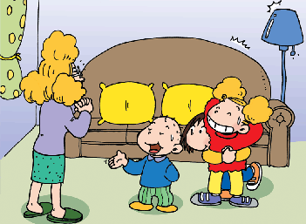
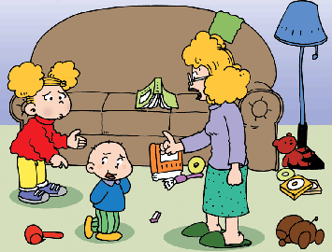
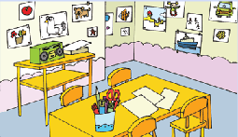
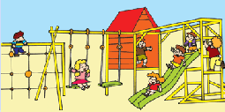
1. 2.

( ) ( ) ( ) ( )
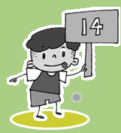
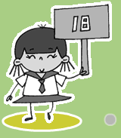
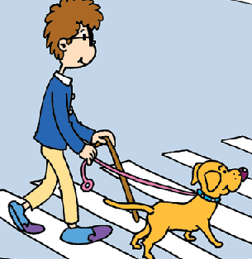
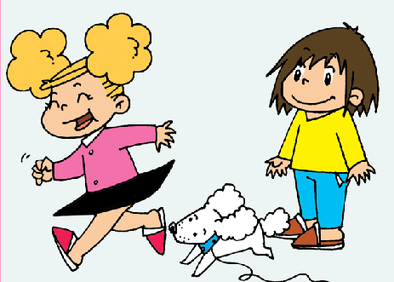
3. 4.

( ) ( ) ( ) ( )

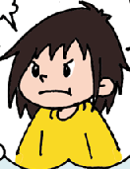
5.

( ) ( )
Ⅱ. Listen and choose. 听问句，选答语。(10%)
( )1. | A. Not very well .
 | B. Yes, you can.
 | C. Yes, I do.
( )2. | A. Yes, I am.
 | B. Yes, she is.
 | C. Yes, he is.
( )3. | A. They start at 7 o’clock..
 | B. It starts at 8:30.
 | C. It finishes at 3:30.
( )4. | A. I’m sad.
 | B. It’s a secret.
 | C. No, I’m not.
( )5. | A. That’s OK..
 | B. You’re welcome.
 | C. I’m sorry.

Ⅲ. Listen and write. 听录音，填上所缺单词，补全句子。(10%)
1. Can you _______ _______? No, I can’t.
2. This dog can _______ ______.
3. We do ___________ _____________.
4. You shouldn’t ________ ________the CDs.
5. You can play ____________ _______.
Ⅳ. Listen and circle. 听短文圈出你听到的单词。(10%)
This is (an, a) English school. There are (children, children’s) paintings on all the (walls, well). There are lots of games. English children can have fun (in, at) break time. They study hard. They do (homework, housework) every day.
V.Listen and choose.听短文回答问题，选择正确答案。 (10%)
( ) 1. Was it raining yesterday?
A. Yes, it was.
B. Yes, it is .
C. No, it wasn’t.
( )2. What did Zara do at home?
A. She helped her mum make a cake.
B. She played.
C. She watched TV .
( )3. Was she hungry and thirsty then?
A. Yes, she was.
B. No, she wasn’t .
C. Yes, they are.
( )4. Did Zara go out to play at last (最后)?
A. Yes, he did. B. Yes, she did. C. No, she didn’t.
( )5. Was Zara happy at last?
A. Yes, she was.
B. No, she wasn’t.
C. No, she didn’t.
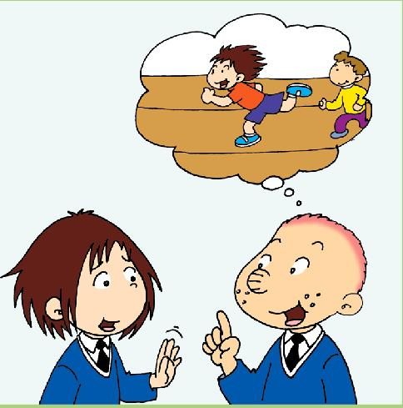
Writing Part 笔答部分
VI．Reorder the words and write. 按照书写要求，用正确规范的形式抄写句子。（10%）
- you/ well/ can/ play/ basketball

- sit/ lines/ in/ we/ in/ China

- you/ should/ kind/ be

- help/ can/ Fifi/ the/ blind/ people

- got/ Sam/ seventeen/ points/ yesterday

VII. Look and write.看图补全句子，每空填一个单词。（10%）
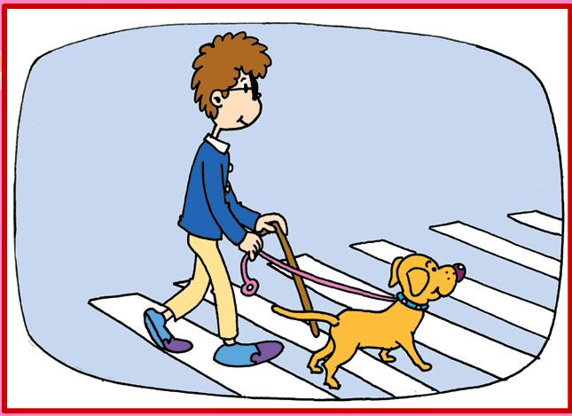
- This __________ dog can help the
___________ people.
- ---Can you _________ _________?
---No, I can’t.
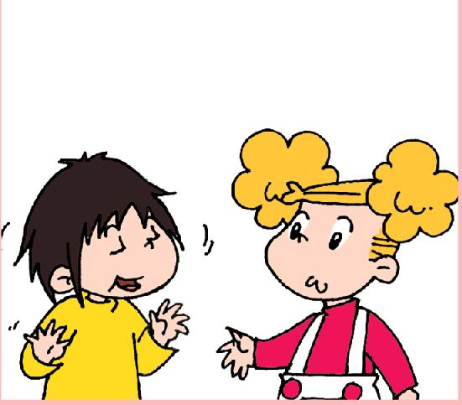
- ---What’s the _________?
--- ____________. I’m thinking.
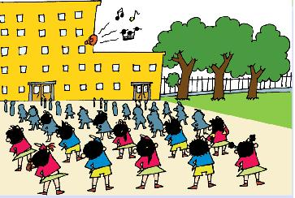
- In China, we do _________
_________.
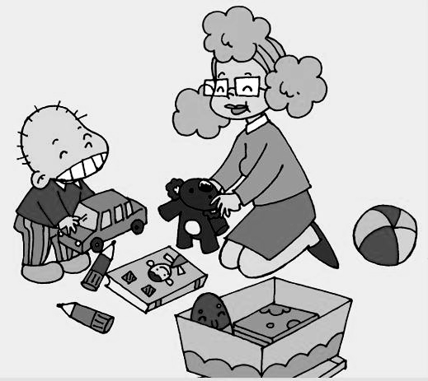
5. You __________ ___________
your toys.

VIII. Read and choose 读一读，选出最佳的词，将字母标号填在题前的括号里。（10%）
（ ）1.This is my bag. It’s________.
- yours B. hers C. mine
( )2.You should try _______.
A. hard B. kind C. late
( )3.There ______children’s paintings on all the walls.
A. is B. are C. /
( )4. The dog found the people. ______the people were safe .
A. But B. Now C. Then
( )5. Yesterday, Amy’s team_____ thirty-six points.
A. get B. getting C. got
IX.Read and judge. 阅读短文，判断句子是否符合短文意思，符合的在括号里划√表示，不符合的划×表示。（5%）
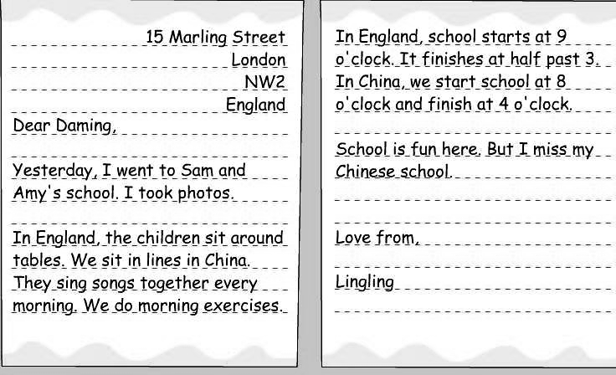

( )1.Our school starts at 9 o’clock.
( )2.This letter is from Lingling to Daming.
( )3.In England ,they do morning exercises.
( )4.We sit in lines in China.
( )5.Lingling took photos there.
X.Listen and choose.读短文，选择最佳答案，将其前面的字母标号填在题前的括号里。
We have rules everywhere（任何地方）. We must follow（遵守）the rules. We shouldn’t run in the classroom. We should try hard at school. We should tidy our room. We shouldn’t make a mess at home. We shouldn’t take the pets（宠物） to the supermarket. We should be quiet (安静) in the cinema （电影院）. We shouldn’t feed animals in the zoo.
If you can follow the rules, you’re a good children.
( )1. Should we follow the rules?
- Yes,you should. B.Yes,we should.
C. No,we shouldn’t.
( )2.We shouldn’t__________ in the classroom.
A. run B. study C. quiet
( )3.---What should we do at home?
---We should__________.
- tidy your room B. make a mess
C. play with toys
( )4. We should be _________ in the cinema.
A. talk B. quiet C. play
( )5. We ________ take the pets to the supermarket.
A. can B. should C. shouldn’t
XI. Composition.以上描述了某些场所的规则，请你仿照短文，为自己的班组制定班规（应该做的，不应该做的），要求语句通顺，内容不少于5句话。（5%）
___________________________________________________
___________________________________________________
___________________________________________________
___________________________________________________
___________________________________________________
___________________________________________________
____________________________________________________

